

**Polish Photoscience Seminar 2018**

**Krutyń, 11-14.6.2018**

**Sponsors:**

* **Institute of Physical Chemistry, Polish Academy of Sciences**
* **LOT-QuantumDesign GmbH**



**Can ultrafast laser spectroscopy   
improve the performance of solar cells?**

Mateusz Gierszewski a, Adam Glinka a, Iwona Grądzka a, Katarzyna Pydzińska a and Marcin Ziółek a

*a Adam Mickiewicz University, Faculty of Physics, Umultowska 85, 61-614 Poznań, Poland*

*e-mail: marziol@amu.edu.pl*

Pulsed laser spectroscopy operating in the femtosecond, picosecond and nanosecond time range has become an important tool for basic research, especially since the award of the Nobel Prize to Ahmed Zewail at the end of the last century. Thanks to the progressive development of electronics and optics, laser spectroscopy techniques are becoming more and more popular instruments enabling observation of the fastest processes occurring in nature. On the other hand, new technologies in the development of solar cells, alternative to expensive silicon photovoltaics, are based on charge separation processes that take place in a wide range of times, also in very short time scales. Using pulsed spectroscopy, we can learn the mechanisms and dynamics of charge transport processes in such devices. But can studies with femtosecond laser pulses be used for more practical purposes and help in achieving better efficiency of solar cells?

In recent two years, we have been developing in our research group time-resolved absorption and emission techniques used for the measurement of dye-sensitized and perovskite solar cells [1]. We specialize in the study of complete, functional cells (for which the basic photovoltaic measurements are performed) as the samples in laser spectroscopy experiments. The main objective is to observe the correlation between measured photovoltaic parameters of solar cells and the results obtained in ultrashort time scale. The examples of the results for which such correlations occur, as well as those for which the correlation cannot be found, will be presented. In particular, some types of the dye-sensitized solar cells will be shown, for which the values ​​of measured photocurrents almost completely depend on processes occurring in times below single nanoseconds. These observations contradict the common belief that the fastest electron transfer processes do not affect the efficiency of such solar cells.

**Acknowledgements**

This work was supported by NCN (The National Science Centre, Poland) under project 2015/18/E/ST4/00196.

**References**

[1] Mater. Chem. Phys. **170** (2016) 218-228; ChemSusChem **9** (2016) 1647-1659; Chem. Eur. J. **22** (2016) 15807-15818; Dyes & Pigments, **141** (2017) 306-315; ACS Appl. Mater. Interfaces, **9** (2017) 17102-17114; Phys. Chem. Chem. Phys., **19** (2017) 20463-20473; Synt. Met. **232** (2017) 181-187; RSC Adv., **8** (2018) 6479-6487; Phys. Chem. Chem. Phys., **20** (2018) 7710–7720.

**Factors affecting ultrafast electron transfer processes in solar cells sensitized with top efficient carbazole dyes**

Adam Glinka a, Mateusz Gierszewski a, Iwona Grądzka a and Marcin Ziółek a

*a Adam Mickiewicz University in Poznań, Faculty of Physics, Umultowska 85, 61-614 Poznań, Poland, e-mail: adagli@amu.edu.pl (AG), marziol@amu.edu.pl (MZ)*

The dye-sensitized solar cells (DSSCs) have attracted major concern in recent years as a cheaper alternative for commercially available semiconductor solar energy conversion devices. The champion solar cells were constructed using titania photoanodes, co-sensitized with ADEKA-1 – carbazole dye with alkoxysilyl anchoring group in combination with cobalt-based electrolytes.1

Without special design of the titania-dye-electrolyte interface, including post-assembly molecular or atomic passivation, cobalt-based solar cells performance is worse than standard iodide-based ones, due to the unwanted back electron transfer from titania to redox couple (occurring on ms-s timescale). Nevertheless, passivating layers affect also dye-semiconductor forward electron transfer what is crucial for power conversion efficiency.2

Another issue except the efficiency of DSSCs is their environmental impact. Consequently, great effort is made to substitute toxic and volatile acetonitrile-based electrolyte solvents with aqueous ones without the loss of their efficiency.3 However, substituting the electrolyte solvent affects not only regeneration of the oxidized dye by redox couple but also electron injection and recombination between dye and titania conduction band and time-stability of DSSCs.

Thus we performed transient absorption measurements to determine rate constants of electron transfer processes occurring in fully assembled and photovoltaic characterized devices in 0.2ps – 3000ps time window, both in VIS and NIR. Solar cells were sensitized with ADEKA-1 dye and its popular carboxylic anchoring analogue MK-2 dye.

Despite completely different modifications (applying passivating layers, changing the electrolyte solvent and swapping dye anchoring unit) in solar cells, essential reasons of decreasing rate constants of electron transfer processes in these systems seem to be common, what points out some fundamental principles of DSSC operation.

**Acknowledgements**

This work was supported by NCN (The National Science Centre, Poland) under project 2015/18/E/ST4/00196.

1. Kakiage, K. *et al. Chem. Commun.* **51**, 15894–15897 (2015).

2. Gierszewski, M., Glinka, A., Gradzka, I., Jancelewicz, M. & Ziółek, M. *ACS Appl. Mater. Interfaces* **9**, 17102–17114 (2017).

3. Bella, F., Gerbaldi, C., Barolo, C. & Grätzel, M. *Chem. Soc. Rev.* **44**, 3431–3473 (2015).

**Femtosecond transient absorption spectroscopy in studies of charge transfer dynamics in ruthenium sensitizers for solar cells and water splitting system**

Mateusz Gierszewski a, Iwona Grądzka a, Adam Glinka a and Marcin Ziółek a

*a Adam Mickiewicz University in Poznań, Faculty of Physics, Umultowska 85, 61-614 Poznań, Poland, e-mail: mgiersz@amu.edu.pl*

Femtosecond transient absorption spectroscopy was used to study the charge transfer dynamics, including electron injection and electron recombination processes, in N719 dye belonging to ruthenium sensitizer for dye-sensitized solar cells (DSSCs) in combination with cobalt-based electrolyte vs. iodide in acetonitrile solution. Moreover, two other ruthenium complexes for water splitting systems: ruthenium sensitizer (RuP) and water oxidation catalyst (RuOEC) were investigated in full dye-sensitized solar cell configuration. Transient absorption measurements were performed after photovoltaic characterization of the cells in 3 ns time window in two spectral ranges: 480-850 nm (VIS) and 800-1500 nm (NIR) and allow to explain the differences between corrected photocurrent of the studied cells [1,2].

Dye-sensitized solar cells based on ruthenium dyes exhibit remarkable stability and are still characterized by the highest certified sunlight conversion efficiency (11.9%). Moreover, recently proposed Co-based electrolytes, instead of iodide one, are much promising to improve the solar cells performance especially for all-organic dyes. Unfortunately, this strategy does not work with classical ruthenium dyes. The total sunlight conversion efficiency in the Co-based cells is only 35-50% of that in iodide ones for the cells sensitized with N719 dye. An important limitation in the photocurrent of cobalt-based cells is revealed to be due to electron recombination between titania and oxidized Ru dyes, which is much higher than that in iodide-based cells and occurs on the time scale of tens and hundreds of ps. Due to the lower absorption coefficients of ruthenium dyes with respect to their organic counterparts, we also investigate the effect of the changes in the titania layer thickness, addition of scattering nanoparticles and modifications in the TiCl4 treatment on the DSSC performance [1].

Finally, comparison between N719 dye and ruthenium complexes for water-splitting systems shows that the relative photocurrent is by 20-50% smaller in RuP cells with respect to that in N719 cells. For RuOEC, the photocurrent is very small (only 25% of that for N719) [2].

**Acknowledgements**

This work was supported by NCN (The National Science Centre, Poland) under project 2015/18/E/ST4/00196.

**References**

[1] M. Gierszewski, I. Grądzka, A. Glinka, M. Ziółek, *Phys. Chem. Chem. Phys.*, 2017, **19**, 20463-20473.

[2] I. Grądzka, M. Gierszewski, J. Karolczak, M. Ziółek, *Phys. Chem. Chem. Phys.*, 2018, **20**, 7710-7720.

**Presentation of the new method: femtosecond infrared pump – stimulated Raman probe spectroscopy and its applications to study vibrational relaxations pathways**

**Marcin Pastorczak1,2, Michał Nejbauer1, Czesław Radzewicz1**

*1Institute of Experimental Physics, Faculty of Physics, University of Warsaw, Pasteura 5, 02-093 Warsaw, Poland*

*2Institute of Physical Chemistry, Polish Academy of Sciences, Kasprzaka 44/52, 01-224 Warsaw, Poland*

*E-mail:* [*marcin.pastorczak@fuw.edu.pl*](mailto:marcin.pastorczak@fuw.edu.pl)

The major goal of the contemporary ultrafast vibrational spectroscopy is to provide researchers with a detail dynamical image of inter- and intramolecular interactions. On the top of the features inherent to vibrational spectroscopy, a potential “perfect” vibrational time-resolved method should provide good time resolution (below 50 fs), spectral resolution better than 10 cm-1 and the possibility of simultaneous recording of dynamical changes in the whole range of molecular vibrations after an impulsive perturbation of the studied system.

In recent years, a step toward the desired method was made thanks to progress in generation of broadband infrared (IR) continuum through laser beam filamentation in air [1]. As a result, broadband IR probe pulses (from around 400 cm‑1 to around 3300 cm-1) were generated and successfully applied in femtosecond IR and 2-dimensional IR spectroscopies [2]. Earlier, this sort of method was attempted to achieve by Kaiser and Laubereau [3] followed by Dlott [4] who applied IR pump – Raman probe scheme in time-resolved experiments. Thanks to inherent features of Raman scattering these methods provide multiplex detection but the time-resolution achieved by the workers was picoseconds either due to the limitations of IR pulses generation at the time (Kaiser & Laubereau) or because of picosecond Raman probe pulse being a trade-off between time and spectral resolution of the method (Dlott).

In this work we propose a new method: femtosecond infrared pump – stimulated Raman probe spectroscopy (fs-IR-SRS). In the femtosecond Stimulated Raman Spectroscopy (FSRS) the Raman transition is induced with two pulses: a narrow-bandwidth picosecond pulse which initializes the Raman transition and a broadband ultrashort probe pulse to stimulate the Raman transition [5]. All information about the system available in this process is contained in a wideband ultrashort probe pulse. The time resolution of FSRS is limited only by the cross correlation of the excitation pulse and the probe pulse, which can be easily below 50 fs. It was demonstrated [6] that the spectral resolution is limited mainly by the Raman pump spectrum and is independent of other pulses used in FSRS. This way one can circumvent a traditional frequency – time transform limitation which applies to standard pump-probe experiments. In our modification of the initial concept of FSRS we replace the visible actinic pulse with a femtosecond infrared pulse which promotes vibrational transition in a system. In the fs-IR-SRS the time resolution of an experiment is limited by duration of IR pulse; which is in around 100 fs.

In the proof-of-concept experiment, we apply the fs-IR-SRS method to study vibrational relaxation pathway in liquid water (H2O) and isotopically diluted water (HDO in D2O). We take advantage of multiplex ability of SRS to probe water spectrum in the broad range of frequencies: 100 cm-1 -4000 cm-1 after infrared excitation of: (1) fundamental (at 3300 cm-1) or (2) overtone (at 6900 cm-1, 0->2 transition) of water OH stretch vibration. As a result we observe vibrational relaxations of the O-H stretching mode and O-D stretching mode (excited through intermolecular energy transfer) in HDO molecule. The observed by us vibrational relaxation times are of the order of few hundred of femtoseconds and are in good agreement with values obtained with pump-probe IR spectroscopy. [7]. Furthermore, we will discuss possible future applications of fs-IR-SRS method in studies of inter- and intramolecular energy transfer in molecular systems.

Research presented here was supported by Polish National Science Center (NCN), project no. UMO-2015/17/B/ST4/04035

[1] P.B Petersen,. and A. Tokmakoff, “Source for ultrafast continuum infrared and terahertz radiation”*.* Opt. Lett., **35**, 1962 (2010)

[2] K. Ramasesha, et al., “Water vibrations have strongly mixed intra- and intermolecular character”*.* Nat. Chem.,**5**, 935 (2013)

[3] A. Laubereau, et al., “Vibrational population lifetimes of polyatomic molecules in liquids”*.* Chem. Phys.,**31**, 335 (1978)

[4] J.Deàk et al. “Vibrational Energy Redistribution in Polyatomic Liquids:  Ultrafast IR−Raman Spectroscopy of Acetonitrile”*.* JPC A, **102**, 8193 (1998)

[5] P. Kukura, et al., “Structural Observation of the Primary Isomerization in Vision with Femtosecond-Stimulated Raman”*.* Science, **310**, 1006 (2005)

[6] Sun, Z., et al., “Quantum theory of (femtosecond) time-resolved stimulated Raman scattering”*.* J Chem Phys, **128**, 144114. (2008)

[7] H.J. Bakker, and J.L. Skinner, “Vibrational Spectroscopy as a Probe of Structure and Dynamics in Liquid Water”*.* Chem Rev, **110**, 1517. (2009)

**How to Burn Water with Sunlight? Insights from Computational Chemistry**

Andrzej L. Sobolewski

*Institute of Physics**, Polish Academy of Sciences, Al. Lotnikow 32/46, 02-668 Warsaw, Poland*

*sobola@ifpan.edu.pl*

Polymeric or partially crystalline materials consisting of *s*-triazine or heptazine (tri-*s*-triazine) units connected by imide groups or nitrogen atoms and collectively referred to as graphitic carbon nitrides (g-C3N4) have received enormous attention since the discovery of their photocatalytic activity for hydrogen evolution with visible light [1] The mechanism of the photoinduced water-splitting reaction catalyzed by g-C3N4 is generally discussed in terms of the band structure of the amorphous or crystalline materials and the mobility of photoinduced electrons and holes which are supposed to eventually drive the reduction of protons and the oxidation of water, respectively. However, the fundamental mechanistic principles of the photoinduced reaction and the catalytic cycle are currently not well understood.

In this contribution, I provide first-principles computational evidence that water splitting with heptazine-based materials [2], as well as with other azines [3,4] and TiO-porphyrines [5,6] is a molecular photochemical process taking place in hydrogen-bonded chromophore-water complexes. The water splitting occurs homolytically via an electronically driven nonadiabatic proton-transfer reaction from water to chromophore, resulting in ground-state hydrogenated molecular radicals and OH radicals. The excess hydrogen atom of the hypervalent molecular radical can be photodetached by a second photon, which regenerates the catalyst, or the long-lived hydrogenated radicals can recombine to yield H2 in a dark reaction when a suitable catalyzer (colloidal platin, for instance) is present. The OH radicals produced in the reaction can be recombined to H2O2 with suitable catalyzers (carbon or metal-oxide nano dots).

References

1. X. Wang, K. Maeda, A. Thomas, K. Takanabe, G. Xin, J. M. Carlsson, K. Domen and M. Antonietti, *Nature Mater*., 2009, **8**, 76.

2. Ehrmaier J., Karsili T.N.V., Sobolewski A.L., Domcke W., J. Phys. Chem. A, **2017**, 121, 4754

3. Liu, X., Sobolewski, A. L., Borrelli, R., Domcke W., *Phys. Chem.* *Chem. Phys***. 2013**, *15*, 5957.

4. Liu, X;Karsili T.N.V., Sobolewski A.L., Domcke W., *Chem. Phys.,* ***2016****, 464, 78.*

5. Morawski O., Izdebska K., Karpiuk E., Suchocki A., Zhydachevskii Y., Sobolewski A.L., Phys. *Chem. Chem. Phys.,* ***2014****, 16, 15256*

6. Morawski O., Izdebska K., Karpiuk E., Suchocki A., Zhydachevskii Y., Sobolewski A.L.,

*J. Phys. Chem. C,* ***2015****, 119, 1408.*

**Theoretical Vibrational Spectroscopy of Hydrogen-Bonded Complexes, Liquids and Solids**

Marek J. Wójcik

*Faculty of Chemistry, Jagiellonian University, 30-060 Kraków, Ingardena 3, Poland*

Theoretical model is presented for the X-H(D) stretching vibrations in hydrogen-bonded systems. The model takes into account an adiabatic coupling between the high-frequency X-H(D) stretching and the low-frequency intermolecular X...Y stretching modes, linear and quadratic distortions of the potential energy for the low-frequency vibrations in the excited state of the X-H(D) stretching vibration, resonance interactions between hydrogen bonds, Fermi resonance between the X-H(D) stretching and the overtone of the X-H(D) bending vibrations, and mechanical and electrical anharmonicities. The effects of deuteration and temperature on spectra are successfully reproduced by the model. Comparison between experimental and theoretical spectra is presented for different hydrogen-bonded systems, including ices. We present also the method of Car-Parrinello molecular dynamics used to calculate infrared spectra of crystals.

Proton tunneling in tropolone is described by two-dimensional model potentials. The potentials have been fitted to quantum-mechanically calculated two-dimensional grid of energies, and used to analyze proton dynamics. The model PES well reproduces experimentally observed promotion of the tunneling by the excitation of the planar modes and suppression by the excitation of the out-of-plane modes.

**Accuracy of spectroscopic constants predicted by explicitly correlated coupled cluster methods.**

Marcin Gronowski

*Institute of Physical Chemistry, Polish Academy of Sciences*

*Kasprzaka 44/52, 01-224 Warsaw, Poland*

Theoretical predictions of rotational constants and vibrational frequencies by high-level quantum-chemical calculations play an important role in guiding spectroscopic studies. The reliable prediction of rotational constants requires: *i* high-level treatment of correlation of valence electrons, *ii* inclusion of correlation of core electrons, *iii* inclusion of a vibrational correction. Usually, in order to get high precision, the basis set limit must be reached. This is easily doable for small molecules, but for larger systems this is still challenging. Explicitly correlated (F12) methods offer a significant improvement in basis set convergence compared to the classical version of coupled cluster methods. In consequence, their application to estimation of spectroscopic constants is an appealing approach to larger molecules.

We have tested different variants of the explicitly correlated coupled-cluster method using the correlation consistent basis set designed for F12 computations. We compared these values to experimental results. Accuracy of rotational constants on the order of 0.1-0.2% can be reached by using the core valence triple zeta basis set and any variant of explicitly correlated coupled cluster single-double and perturbative triple (CCSD(T)-F12). Further improvements can be obtained by applying a larger basis set

Statistical analysis was based on the results obtained for 22 closed-shell molecules, including both saturated and unsaturated molecules. For unsaturated hydrocarbons (like ethylene, C2H4), correlation of core electrons is far more important than for saturated hydrocarbons (like ethane, C2H6). This is true for both rotational constants and vibrational frequencies.

**SERS spectroscopy in biomedical and analytical applications**

Agnieszka Kamińskaa,* Evelin Witkowskaa, Krzysztof Nicińskia, Tomasz Szymborskia, Aneta Kowalskaa,Dorota Korsakb, Jacek Waluk

a Institute of Physical Chemistry, Polish Academy of Sciences, Kasprzaka 44/52, 01-224 Warsaw, Poland

bDepartment of Molecular Biology, Institute of Biochemistry, Faculty of Biology, University of Warsaw, 02-096 Warsaw, Poland

Surface-enhanced Raman scattering coupled with principal component analysis can serve as a fast, reliable and easy method for detection and identification of the most common meningitis pathogens, *Neisseria meningitidis, Haemophilus influenzae*, and *Streptococcus pneumoniae* identified in clinical cerebrospinal fluid (CSF) samples. The newly developed SERS class of assay is based on combination of two types of Au-Ag coated nuclepore track-etched polycarbonate membranes, which allows simultaneous filtration of CSF, immobilization of CSF components, enhancing their Raman signals, and, finally, enabling detection of spectra of single bacteria present in the analyzed CSF samples. The multivariate statistical method, principal component analysis (PCA) was applied (i) to extract the biochemical information from the recorded bacterial spectra; (ii) to perform the statistical classification of analyzed microorganisms, and, finally (iii) to identify the spectrum of an unknown sample by comparing it to the library of spectra of known bacteria. This method of detection produces consistent results faster and cheaper than traditional laboratory techniques and demonstrates the powerful potential of the SERS technique in medical applications.

Additionally, the present study was undertaken to evaluate the CSF neopterin level in patients with diagnosed meningococcal meningitis. The results of this study confirmed that bacterial meningitis caused by *N. meningitidis*, *H. influenzae*, and *S. pneumoniae* are associated with elevated cerebrospinal fluid neopterin levels compared with control CSF samples. The value of neopterin concentration can be used to predict meningitis, but it cannot be applied to qualify the species of bacteria inducing the meningitis infection.

The SERS-active platform incorporated into the microfluidic device permits label-free detection and identification of isolated cells through the insight into their molecular structure and biochemical composition. Isolation and detection of circulating tumor cells (CTCs) from human blood plays an important role in non-invasive screening of cancer evolution and in predictive therapeutic treatment. Here, we present a novel tool utilizing: (i) the microfluidic device with (ii) incorporated photovoltaic-based SERS-active platform, and (iii) shell-isolated nanoparticles (SHINs) for simultaneous separation and label-free analysis of circulating tumor cells CTCs in the blood specimens with high specificity and sensitivity. The proposed microfluidic chip enables the efficient size – based inertial separation of circulating cancer cells from the whole blood samples.

**Acknowledgments**

We would like to thank prof. A. Skoczyńska from National Medicines Institute, Warsaw, Poland for clinical CSF samples and J. Trzcińska-Danielewicz from Department of Molecular Biology, Faculty of Biology, University of Warsaw, Poland for CTCs cultivation.

The authors acknowledge support from Foundation for Polish Science under grant Team Tech/2017-4/23.

**Raman study of focal epilepsy in rats using 2D COS**

Julia Sacharza, Aleksandra Wesełucha-Birczyńskaa, Janina Zięba-Palusb, Łukasz Chrobokc, Katarzyna Palus-Chramiecc, Marian H. Lewandowskic

*a Faculty of Chemistry, Jagiellonian University, Krakow, Poland,* [*julia.sacharz@uj.edu.pl*](mailto:julia.sacharz@uj.edu.pl)*; b Institute of Forensic Research, Krakow, Poland; c Department of Neurophysiology and Chronobiology, Institute of Zoology and Biomedical Research, Jagiellonian University, Krakow, Poland*

The aim of this study was to use Raman microspectroscopy as a diagnostic method for searching biomarkers of genetic focal epilepsy in red blood cells. Epilepsy is characterized by unpredictable recurrent seizures that manifest as general convulsions until a brief loss of consciousness, which is caused by asynchronous or abnormal overactive neuronal brain networks [1]. The recent studies have shown that after seizures prolactin was detected in blood serum [2]. However, there seem to be interesting to verify the advantage of standard blood tests and check if we could diagnose genetic focal epilepsy before the seizures appearance. In this work we have presented an innovative study that was performed on single red blood cells using Raman microspectroscopy. The research groups were two weeks old male Wistar rats - representing the control group (healthy) and WAG/Rij rats - representing the epileptic group. Rats of the WAG/Rij strain are an experimental model of absence epilepsy [3]. Raman spectra were collected using Renishaw inVia spectrometer equipped with Leica microscope and excitation source lasers: 442 nm, 514.5 nm and 785 nm. 2D correlation analysis was performed using the Noda method [4]. Raman average spectra were used as input data while the laser line was regarded as an external perturbation in 2D correlation.

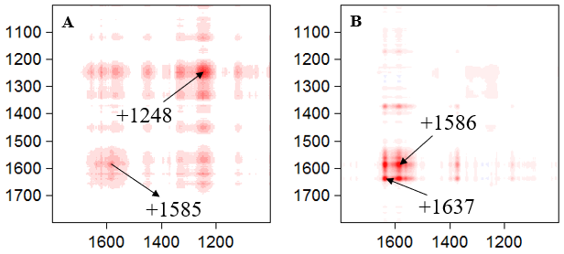

**Figure 1** 2D correlation synchronous spectra of the healthy (A) and epileptic (B) red blood cell in the 1800-1000 cm-1 spectral range.

The fingerprint range showed differences between healthy and epileptic cell spectra. 2D synchronous correlation spectra showed auto-peaks at 1248 cm-1 (amide III (β-sheet); ν42, δ(CmH) (oxy Hb)) and 1585 cm-1 (Trp; ν37, ν(CαCm)asym) for healthy red blood cell and auto-peaks at 1586 cm-1 (Trp; ν37, ν(CαCm)asym) and 1637 cm-1 (amide I (α-helix); ν10, ν(CαCm)asym) for epileptic red blood cell [5]. Concluding epileptic erythrocytes present changes in their chemical composition and Raman spectroscopy might be the helpful tool for finding the epilepsy biomarkers in the blood.

Julia Sacharz acknowledges the financial support from National Science Centre (Poland), decision DEC-2017/01/X/ST4/01977.

[1] A. Longstaff, *Krótkie Wykłady. Neurobiologia*, 2012, red: A. Wróbel, PWN, Warszawa

[2] D. K. Chen, Y. T. So, R. S. Fisher, *Neurology*, 2005, **65**: 668–675

[3] L. Chrobok, K. Palus, M. H. Lewandowski, *Neuropharmacology*, 2016, **103**: 236–246

[4] I. Noda, 1993, **47**: 1329-1336

[5] M. Kozicki, J. Czepiel, G. Biesiada, P. Nowak, A. Garlicki, A. Wesełucha-Birczyńska, *Analyst*, 2015, **140**: 8007-8016

**Raman Spectroscopy Characterization of Carbon Polymer Nanocomposites**

**Anna Kołodziej1, Aleksandra Wesełucha-Birczyńska1, Małgorzata Świętek2, Łukasz Skalniak1, Marta Błażewicz3**

*1 Faculty of Chemistry, Jagiellonian University, Kraków, Poland;* [*anna.dziej@gmail.com*](mailto:anna.dziej@gmail.com)

*2Institute of Macromolecular Chemistry, Academy of Sciences of the Czech Republic, Prague 6, Czech Republic*

*3Faculty of Materials Science and Ceramics, AGH-University of Science and Technology, Kraków, Poland*

Tissue engineering medicine is a multi-disciplinary field of biomaterial science that aims   
to introduce new substitutes to repair or replace damaged tissues. Despite many successes in this field, materials widely used in regenerative medicine applications still need to be improved [1]. From among lots of tasks that tissue engineering deals with, emerges the necessity of developing a 3D scaffold that could replace/regenerate the human bone tissues. The biodegradable polymers such   
as poly(ε-caprolactone) (PCL) is a candidate that can fulfill this task due to its physical and biological properties and also a long time of degradation. However, it was proved that pure PCL does not meet the criteria of biocompatibility and mechanical properties well enough for bone tissue engineering  
[2, 3]. This problem is expected to be overcome by modifying PCL with nano-additives such  
as nanotubes/nanofibres, which exhibit a superior cytocompatibility, and improved electrical and mechanical properties [1, 4].

The materials studied and analysed as membranes were obtained by introduction of raw   
or functionalized multi-walled carbon nanotubes (MWCNT;MWCNTf) and carbon nanofibres (CNF;CNFf) into a poly(ε-caprolactone) matrix. The number of nano-additives makes up 1% of polymer nanocomposites. The reference membrane was obtained from unmodified PCL.   
The aim of current study was to decode the phenomenon that occurs in the polymer in contact with the nanoparticles.

Raman microspectroscopy was used as a method to determine the degree of crystallinity for both surfaces (top and bottom) of thin nanocomposite membranes. It was checked that the most suitable laser wavelength for this goal is 514,5 nm line. In almost all materials, a greater amorphism was characteristic for the top face of the membrane. The heterogeneity of both nanomaterials surfaces was revealed by performing a linear Raman mapping on both surfaces of materials. Raman mapping with the 1064 nm line as an excitation source was used to determine the heterogeneity of a reference membrane (unmodified PCL).

The appearance of characteristic polymer matrix bands was well seen in the Raman spectra   
of all measured nanocomposites. In addition, there were also present the broad bands at 1600 cm-1 and 1350 cm-1 that come from carbon nanoparticles. Interactions of carbon nanotubes and carbon nanofibres with polymer matrix differ. The functionalization of nanocomposites also affects their specificity.

Raman microspectroscopy turned out to be a useful method to study the interaction   
at the interface of the polymer and the nanoparticles.

**Acknowledgement.**

This project was financed from the National Science Centre (NCN, Poland) on the decision 2013/09/B/ST8/00146   
and 2014/13/B/ST8/01195. AK has been partly supported by the EU Project POWR.03.02.00-00-I004/16.

**References:**

1. Zhang L, Webster TJ.*.* Nano Today, 2009 Feb;4(1):66-80.
2. Di Foggia M, Corda U, Plescia E, Taddei P, Torreggiani A*.* J Mater Sci Mater Med. 2010 Jun;21(6):1789-97.
3. Abedalwafa M, Wang F, Wang L, Li C. Rev. Adv. Mater. Sci. 2013, 34:123–140.
4. Wesełucha-Birczyńska A, Swiętek M, Sołtysiak E, Galiński P, Płachta Ł, Piekara K, *et al.* Analyst. 2015 Apr;140(7):2311-20.

**SERS-based detection and strain level typing of *Listeria monocytogenes* - a step towards development of food microbiology**

**Evelin Witkowskaa, Dorota Korsakb, Krzysztof Nicińskia, Agnieszka Kamińskaa**

a*Institute of Physical Chemistry, Polish Academy of Sciences, Kasprzaka 44/52, 01-224 Warsaw, Poland*

b*University of Warsaw, Faculty of Biology, Department of Applied Microbiology, Miecznikowa 1, 02-096 Warsaw, Poland*

*ewitkowska@ichf.edu.pl*

Surface-enhanced Raman spectroscopy (SERS) coupled with principal component analysis (PCA) can serve as a fast, reliable, and easy method for detection and identification of bacteria. In the following work we focus on the detection of foodborne *Listeria monocytogenes* in different types of food matrices (*e.g.* salmon, ham). This is an important issue, as among 2,536 confirmed human cases of listeriosis in 2016 in EU, 247 were fatal.1 This number places listeriosis as the most dangerous foodborne pathogen. Our study demonstrates that the SERS technique is effective in distinguishing closely related bacteria (within single genus) grown both on solid and liquid media. The advantages of the proposed ISO (International Standarization Organization) - SERS method for bacteria identification include simplicity and reduced time of analysis, from almost 144 h required with use of standard methods to 48 h for the SERS-based approach. Furthermore, PCA allows to perform statistical classification of studied bacteria and to identify the spectrum of an unknown sample. Calculated first and second principal components (PC-1, PC-2) account for 98% of total variance in the spectra and enable to identify *L. monocytogenes*.2

We also demonstrate that SERS-PCA based technique serves as a perfect method for taxonomic affiliation of bacteria on the strain level. More specifically, we prove that it is possible to differentiate between *L. monocytogenes* strains belonging to: i) different genoserogroups and ii) single genoserogroup. The differences in the first case are based on the variance in cell surface antigens, and in the second case - on the presence of additional proteins in bacterial cell membrane, *e.g.* CadA1, CadA2 (proteins determining resistance to Zn2+, Cd2+, Pb2+, encoded by *cadA1* and *cadA2* genes, respectively), BcrB and BcrC (proteins determining resistance to benzalkonium chloride, encoded by *bcrABC* gene). These changes are expressed in the SERS spectrum. Further development of this method may serve in clinical laboratories to define whether the analyzed bacterium is able to contaminate food samples/disinfectants and thus whether it is dangerous for humans.

The authors would like to acknowledge the support from Foundation for Polish Science under grant Team Tech/2017-4/23.

_____________________

1 European Food Safety Authority. EFSA Journal 15 (2017) 5077.

2 E. Witkowska, D. Korsak, A. Kowalska, M. Księżopolska-Gocalska, J. Niedziółka-Jönsson, E. Roźniecka, W. Michałowicz, P. Albrycht, M. Podrażka, R. Hołyst, J. Waluk, A. Kamińska, Anal. Bioanal. Chem., 409 (2017) 1555-1567.

**Interface ligand exchange and relaxation processes in nanocomposites “CdSe/ZnS quantum dot – dye”: bulk experiments and detection of single nanoobjects**

**Eduard Zenkevich1, Alexander Stupak2, Thomas Blaudeck3, Danny Kowerko3, Stefan Krause4, Christian von Borczyskowski3**

*1Department of Information Technologies and Robotics, National Technical University of Belarus, Prospect Nezavisimosti 65, 220013 Minsk, Belarus, zenkev@tut.by*

*2B.I. Stepanov Institute of Physics, National Academy of Sciences of Belarus, Prospect Nezavisimosti 70, 220072 Minsk, Belarus*

*3Institute of Physics and Center for Nanostructured Materials and Analytics, Technische Universität Chemnitz*

*Reichenhainer Str. 70, D-09107 Chemnitz, Germany*

*4Department of Chemistry, University of Copenhagen, Universitätsparken 5, 2100 Copenhagen, Demark*

Semiconductor quantum dots (QDs) being a novel class of fluorophore with unique photoluminescence (PL) properties, high photochemical stability and tuned size/optical parameters, are the focus of research in optoelectronics, biology and nanomedicine. 

Figure 1

Here, we present a detailed analysis of static and dynamic PL quenching (*via* spectral intensities and/or PL decays) obtained for bulk and single nanoassemblies based on semiconductor CdSe or Cdse/ZnS QDs and *meso*-pyridyl substituted porphyrins (Fig. 1) in liquid solvents and on rigid carrier at 293 K. For these nanoassemblies, FRET amounts at maximum to 10 % of the QD PL total quenching efficiency. The attachment of porphyrin molecules occurs preferentially to those QDs with low ligand coverage, and nanoassembly formation deviates strongly from Poisson statistics. Alike FRET, non-FRET depends on the QD size. Non-FRET quenching is caused by the formation of specific new Cd2+ trap states following depletion of several ligands by the spacious dye molecules. While FRET follows quantitatively the Foerster model, non-FRET results (within 1-3 ns) in new and enhanced long-lived weakly emitted intra-gap states.

The obtained results demonstrate that on the basis of the combination of steady-state and time-resolved measurements for bulk and single QD-dye nanoassemblies, it is in principle feasible to follow non-radiative pathways from near-band-edge states to intra-gap states thus investigating microscopic features of surface related energy distributions and decay channels.

**Acknowledgment**

This work was supported by Belarussian State Program for Scientific Research “Convergence 2020” and the Volkswagen Foundation (Priority Program “Physics, Chemistry and Biology with Single Molecules”).

**References**

1. Zenkevich E., von Borczyskowski C., (Eds.). *Self-Assembled Organic-Inorganic Nanostructures: Optics and Dynamics,* Pan Stanford, Singapore: 2016.

**Photophysics of the triplet state in single-molecule studies**

Bolesław Kozankiewicz

Institute of Physics of the Polish Academy of Sciences, Warsaw

The fluorescence signal of a single molecule is emitted as bunches of fluorescence photons separated by periods when this molecule occupies the long-lived triplet state. The requirement for seldom passage in the triplet state and short time which a molecule spend in this state are the very important factors contributing to single-molecule investigations, even strongly reducing the number of compounds accessible for studies by this technique.[1]

The most convenient approach to deduce the triplet state population and depopulation rates at the single-molecule level is by analysis of the second order fluorescence autocorrelation function, which measures the temporal distribution of the probability to find a photon at time t+τ if a first photon was detected at time t. The analysis performed for single molecules of terrylene (Tr) in a p-terphenyl crystal at liquid helium temperatures allowed to access different population and depopulation rates for the zero magnetic field triplet state spin sublevels, and when the temperature increased to study the spin-lattice relaxation which coupled these sublevels.[2] Further increase of temperature lead to thermal activation of the intersystem crossing rates and appearance of a new triplet-triplet absorption channel, T1→Tn→S1.[3]

Investigation of single terrylene molecules in an anthracene crystal allowed to discover a new, two-step relaxation channel, which starts with an intermolecular intersystem crossing from the S1 state of Tr to the excitonic state of the host, anthracene, followed by a Dexter transfer back to the T1 state of Tr.[4] Such a mechanism, operating whenever the lowest triplet state of a host matrix is located between the S1 and T1 states of the guest molecule, limits the number of systems suitable for the single-molecule studies and was never proved for ensembles of molecules. It is interesting to notice that the external heavy-atom effect has often negligible influence on the possibility of the detection of single molecules.[5]

[1] B. Kozankiewicz, M. Orrit, *Single-molecule photophysics, from cryogenic to ambient condition*, Chem. Soc. Rev. 43 (2014) 1029-1043.

[2] M. Białkowska, A. Makarewicz. M. Banasiewicz,, B. Kozankiewicz, *Spin-lattice relaxation and intersystem-crossing in single molecule of terrylene embedded in a p-terphenyl crystal*, Chem. Phys. Lett. 555 (2013) 131-134.

[3] M. Banasiewicz, O. Morawski, D. Wiącek, B. Kozankiewicz, *Triplet population and depopulation rates of single terrylene molecules in p-terphenyl crystals*, Chem. Phys. Lett. 414 (2005) 374-377.

[4] A. Nicolet, M. Kol’chenko, B. Kozankiewicz, M. Orrit, *Intermolecular intersystem-crossing in single-molecule spectroscopy:terrylene in anthracene crystal*, J. Chem. Phys. 124 (2006) 164711.

[5] M. Białkowska, W. Chaładaj, I. Deperasińska, A. Drzewiecka-Antonik, A. Kozioł, A. Makarewicz, B. Bozankiewicz, *Single molecules of terrylene in di-substituted naphthalenes crystallizing in the herringbone pattern*, RSC Adv. 7 (2017) 2780-2788.

Revealing current-induced emission mechanism in an STM setup: a view from nonadiabatic molecular dynamics

Joanna Jankowska

Institute of Physics, Polish Academy of Sciences, 02-668 Warsaw, Poland

Current-induced fluorescence experiments constitute a convenient tool for probing electronic structure of single molecules. In a typical realization of such experiment, a chromophore molecule deposited on an oxide-coated metal surface interacts with a metal tip of a scanning tunneling microscope. When a bias above certain threshold is applied to the system, the current flows and light emission is observed. Over the recent years, since the current-induced fluorescence experiments developed into an established spectroscopic technique, an intense debate on the exact mechanism of the charge transfer and the light emission is still taking place.

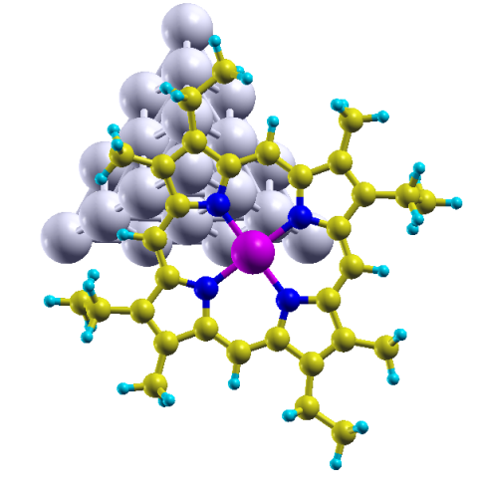Here, we would like to report for the first time a fully atomistic, real-time non-adiabatic dynamic study on a molecule-and-tip system under simulated bias conditions. We analyze the mechanism and dynamics of the charge injection from the tip to molecule and subsequent relaxation of the charge within the molecular subunit. Our findings explain the experimentally observed bias threshold values for the setup including silver-tip and a Zn(II)-etioporphyrin molecule. We reconstruct the observed sharp spectrum features and propose the explanation for the correlation between their intensity and the applied bias. We believe that the reported results bring new insights into the fundamental mechanisms standing behind the current-induced fluorescence experiments and may help with identification of the primary factors determining the observed emission spectra.

**Figure 1:** Zn(II)-etioporphyrin I molecule and Ag20 tetrahedral cluster representing the silver STM tip.

**Optical spectroscopy of single UPC nanocrystals**

Bartosz Krajnika, Lukasz Golackia, Uliana Kostivb, Daniel Horakb, Grzegorz Pawlika,   
Artur Podhorodeckia

1. Department of Experimental Physics, Wroclaw University of Science and Technology,   
   Wyb. Wyspianskiego 27, 50-370 Wroclaw, Poland
2. Institute of Macromolecular Chemistry, Academy of Sciences of the Czech Republic,   
   Heyrovskéhonám. 2, 162 06 Prague 6, Czech Republic

Rare-earth doped up-converting nanocrystals (UPC NCs) have been thoroughly investigated due to their potential application in photovoltaic, medicine and photonics[1,2]. Due to the multicolour luminescence that is accessible with near infrared (NIR) excitation, they are attractive probes for fluorescence microscopy. The usage of NIR light reduces autofluorescence and extends penetration depth in biological samples. Because the ions are embedded in host matrix, they are very well isolated from the environment. It results in lack of photobleaching and very stable emission over tens of minutes. However, UPC NCs are characterized with low quantum efficiency, not higher than 2%. Therefore, the spectroscopic studies of single NCs are demanding. Although, such experiments are important to understand the ion-ion interaction (energy transfer, energy migration, cross-relaxation, etc.) which is needed to improve the optical properties of the UPC NCs[3].

In this work, we investigate the NaYF4:Yb3+, Er3+ NCs at the single nanoparticle level, using custom-build widefield fluorescence microscope equipped with high resolution imaging monochromator. In particular, we measure the luminescence spectra of single UPC NCs and estimate green to red ratio of the emission bands for different power densities. This allows us to control the optical properties of individual NCs and better understand the mechanism responsible for the excited carriers recombination (radiative and non-radiative). Furthermore, we investigate the luminescence intensity dependence of NCs with core and core-shell structure for different Er3+ concentration to get an insight into the mechanism of ion-ion interaction. It is important, since the energy migration is the main mechanism responsible for non-radiative energy loss in NCs. The better understanding of the energy distribution and energy transfer within the single UPC NCs is essential for optimization of this nanostructures and their practical application.

[1] U. Kostiv et al., ChemMedChem, 2066, 11 (2017)

[2] A. Wozniak et al., RSC Advances, 95633, 6 (2016)

[3] A. Noculak et al., Nanoscale, 13784, 7 (2015)

**Strong plasmonic enhancement on DNA-Origami based optical antennas**

*Izabela Kaminska1,2, Caroline Vietz2, Johann Bohlen2,3, Guillermo P. Acuna2, Philip Tinnefeld2,3*

*1 Institute of Physical Chemistry of the Polish Academy of Sciences, Kasprzaka 44/52, 01-224 Warsaw, Poland   
2 Braunschweig Integrated Centre of Systems Biology, Institute of Physical and Theoretical Chemistry, TU Braunschweig, Rebenring 56, 38106 Braunschweig, Germany  
3 Lehrstuhl für Physikalische Chemie, Ludwig Maximilians-Universität München,* [*Butenandtstr. 11*](https://maps.google.com/?q=Butenandtstr.+11&entry=gmail&source=g) *Haus E81377 München, Germany*

*Email: ikaminska@ichf.edu.pl*

Self-assembled DNA origami is an emerging tool for nanofabrication of well-designed programmable structures.1,2 With this technique one can easily arrange nanoparticles (NPs) and molecules with nanometer precision in three dimensions. This enables facile functional hybrid platforms with unprecedented control.

Optical antennas (OAs), consisting typically of two metallic nanostructures placed in close vicinity forming a nanometric gap, have become a powerful tool for single-molecule detection up to micromolar concentrations. DNA origami technology enables parallel fabrication and the positioning of the fluorescent dye inside the OA gap with nanometer precision.3 However, for both top-down and bottom-up approaches containing gold nanostructures, fluorescence enhancement is restricted to the red-infrared spectral range. This shortcoming strongly limits the implementation of OAs for multicolor applications involving the detection of different species.

In this contribution, we demonstrate that using Ag colloidal NPs we obtain strong fluorescence enhancement in the blue, green and red spectral range.4 While for Au colloidal NPs such strong enhancement is achieved only in the red region of the visible spectrum. This is a step towards using self-assembled DNA origami based optical antennas in DNA sequencing or molecular diagnostics where multiplexing is highly required. Moreover, we integrate natural light-harvesting complex with OAs based on a DNA origami pillar and metallic nanoparticles.5 This is the first experimental realization of the system in which a photosynthetic protein is positioned in the nanoantenna hotspot in a controlled manner with nanometer precision. This approach shows promises for fabrication biohybrid photonic devices and sensors composed of DNA origami, metallic nanoparticles and naturally evolved photosynthetic complexes.

IK acknowledges support by the Mobility Plus grant 1269/MOB/IV/2015/0 from the Polish Ministry of Science and Higher Education (MNiSW).

1. P. W. K. Rothemund, Nature 440 (2006) 297.

2. C. E. Castro, F. Kilchherr, D.-N. Kim, E. L. Shiao, T. Wauer, P. Wortmann, M. Bathe, H. Dietz, Nature Methods 8 (2011) 221.

3. G. P. Acuna, F. M. Möller, P. Holzmester, S. Beater, B. Lalkens, P. Tinnefeld, Science 338 (2012) 506.  
4. C. Vietz, I. Kaminska, M. S. Paz, P. Tinnefeld, G. Acuna, ACS Nano 11 (2017) 4969.

5. I. Kaminska, J. Bohlen, S. Mackowski, P. Tinnefeld, G. P. Acuna, ACS Nano 12 (2018) 1650.

**Detecting intramolecular double proton transfer reaction in single molecules using fluorescence microscopy**

Łukasz Piątkowski1, Agnieszka Jamrozik1, Victoriya Kim2, Maria Pszona1, Christina Schanbacher2, Regina Jäger2, Frank Wackenhut2, Jakub Ostapko1, Jerzy Sepioł1, Alfred J. Meixner2 and Jacek Waluk1,3

(1) *Institute of Physical Chemistry, Polish Academy of Sciences, Kasprzaka 44/52, 01-224 Warsaw, Poland*

(2) *Institute of Physical and Theoretical Chemistry, University of Tübingen, Auf der Morgenstelle 18, D-72076 Tübingen, Germany*

(3) *Faculty of Mathematics and Science, Cardinal Stefan Wyszynski University, Dewajtis 5, 01-815 Warsaw, Poland*

Contact e-mail: [lpiatkowski@ichf.edu.pl](mailto:lpiatkowski@ichf.edu.pl); waluk@ichf.edu.pl

Porphycenes, the structural isomers of porphyrins, possess an intriguing property of undergoing ultrafast (fs-ps) interconversion between two chemically identical forms. This process involves migration of hydrogens accompanied by a chemical bond rearrangement, a process known as tautomerization.

Double hydrogen transfer was monitored in single molecules of parent porphycene and its tetra-*t*-butyl derivative using confocal fluorescence microscopy. For the molecules that were embedded in a polymer matrix, we found that a significant fraction of the population exhibited a huge decrease of the tautomerization rate (seconds) with respect to the values obtained from ensemble studies in solution (femto-pico-seconds).1 This effect can be explained by a model that assumes that the tautomerization rate is determined by the slow relaxation and reorganization of the polymer matrix in the direct vicinity of the porphycene. The model provides an indirect evidence for the dominant role of tunneling in the tautomerization reaction. We propose that tautomerization in single molecules of the porphycene family can be used to probe polymer relaxation dynamics on the time scale ranging from femtoseconds to minutes.

Parent hemiporphycene, a recently obtained constitutional isomer of porphyrin, also exists in room temperature solutions and polymer matrices in the two *trans* tautomeric forms.2 Using confocal fluorescence microscopy, it was possible to monitor tautomerization in single hemiporphycene molecules embedded in a PMMA film by monitoring spectral and temporal evolution of fluorescence. While the emission spectra of the two tautomeric forms are similar to those obtained from ensemble studies, the analysis of temporal spectral evolution revealed effects not detected in the bulk. For some single molecules, large decrease of tautomerization rate was observed, evident from the splitting of the emission spectrum into two components characteristic for the two tautomeric forms. This is interpreted as indication of multidimensional character of the tautomerization coordinate and coupling of the reaction with the polymer relaxation processes.

1. Piatkowski, L.; Schanbacher, C.; Wackenhut, F.; Jamrozik, A.; Meixner, A. J.; Waluk, J., J. Phys. Chem. Lett. 2018, 9, 1211-1215.

2. Ostapko, J.; Nawara, K.; Kijak, M.; Buczyńska, J.; Leśniewska, B.; Pietrzak, M.; Orzanowska, G.; Waluk, J., Chem. Eur. J., 2016, 22, 17311–17320.

Double hydrogen transfer in porphycenes – effects of structure and environment

Piotr Kasprzyckia, Piotr Ciąćkab, Arkadiusz Listkowski,c Jacek Walukb,c,

Piotr Fitaa

aInstitute of Experimental Physics, Faculty of Physics, University of Warsaw, Pasteura 5, 02-093 Warsaw, Poland

b Institute of Physical Chemistry, Polish Academy of Sciences, Kasprzaka 44/52, 01-224 Warsaw, Poland

c Faculty of Mathematics and Natural Sciences, College of Science, Cardinal Stefan Wyszyński University, Dewajtis 5, 01-815 Warsaw, Poland

In the past we studied double hydrogen transfer in a number of porphycene derivatives (Fig. 1) in solutions at room temperature and found that the rate of the process is directly related to the donor-acceptor N-N distance and strength of the intramolecular hydrogen bonding, expressed as the chemical shift of transferred protons and calculated N-H oscillation frequency [1]. These experiments suggested that the effect of the environment is rather weak compared to the influence of the above-mentioned parameters. Nevertheless, later measurements carried out at cryogenic conditions, besides revealing that tunneling is the dominant mechanism of the process [2], showed that the environment may control the hydrogen transfer when the temperature of the system is low enough. In the presentation I will give an overview of earlier experiments and discuss the effects of the environment in more detail.

**Fig. 1.** Scheme of double hydrogen transfer in porphycene

References

1. P. Ciąćka, P. Fita, A. Listkowski, M. Kijak, S. Nonell, D. Kuzuhara, H. Yamada, C. Radzewicz, J. Waluk, J. Phys. Chem. B **119**, 2292-2301 (2015).

2. P. Ciąćka, P. Fita, A. Listkowski, C. Radzewicz, J. Waluk, J. Phys. Chem. Lett. **7**, 283-288 (2016).

photoCHEMISTRY OF ACETOHYDROXAMIC ACID in SOLID argon.

FTIR and theoretical studies

Magdalena Sałdyka

Faculty of Chemistry, University of Wrocław, F. Joliot-Curie 14,

50-383 Wrocław, Poland

[magdalena.saldyka@chem.uni.wroc.pl](mailto:magdalena.saldyka@chem.uni.wroc.pl)

Hydroxamic acids (RCONHOH) exhibit a wide spectrum of biological activities [1] that stimulated progress in the chemistry of this class of compounds. They are known to be involved in iron transport phenomena, and are active as antibiotics, antitumor and antifungal agents, and specific enzyme inhibitors.[2] Extensive work has been carried out on the formation of hydroxamic acids, their reactions and structure in the ground state. However, the photochemical properties of hydroxamic acids are still not well recognized. The knowledge of the excited-state behaviour of hydroxamic acids is very important as many of these compounds, on exposure to sunlight, may be transformed to intermediates and photoproducts that are more toxic than parent compounds. According to the literature, photoirradiation of this class of compounds may lead to the initial photolytic scission of the N-O bond or to the acylaminoxyl radical generation.[3]

The literature reports on the structural properties of acetohydroxamic acid (AHA) inform that the stability of different conformers of AHA is strongly dependent on the environment.The studies on the tautomeric and structural properties of acetohydroxamic acidshowed that AHA trapped from the gas phase into solid argon exists in the matrix predominantly as the 1*Z* keto isomer with intramolecular hydrogen bond. The 1*E* keto form is also present in equilibrium with the 1*Z* keto one, however its population is low with respect to the 1*Z* keto isomer.[4]

The importance of the AHA molecule for pharmaceutical applications triggers questions about the influence of UV-VIS irradiation on the structure and photochemical properties of AHA. The performed irradiation of acetohydroxamic acid isolated in argon matrices with full output of a Xe arc lamp or to 225 nm OPO radiation promotes the isomerization, 1Z → 1E, and AHA photodissociation reactions.[5] Four pairs of coproducts are experimentally found in the photolysis, they form the complexes: CH3OH⋅⋅⋅HNCO (1), H2O⋅⋅⋅CH3NCO (2), H2O⋅⋅⋅CH3CNO (3) and CO⋅⋅⋅CH3NHOH (4). The structures of the complexes were optimized at the MP2 computational level with the aug-cc-pVTZ basis set. Three local minima were predicted for the complex (1), two for the complexes (2) and (3) and four local minima were found for the complex (4). The comparison of the theoretical spectra with the experimental ones allowed to determine the structures of the complexes formed in the matrix. The mechanisms of the reaction channels leading to formation of the four co-products are proposed. It is concluded that the first step in formation of the (1), (2) and (3) complexes is the scission of the N-O bond, whereas the creation of the complex (4) is due to the cleavage of the C-N bond.

[1] Kehl H. (Ed.), *Chemistry and Biology of Hydroxamic Acids*, Karger, New York (1982)

[2] Gupta S.P. (Ed.) *Hydroxamic acids: A unique family of chemicals with multiple biological activities*, Springer-Verlag, Berlin Heidelberg (2013)

[3] Lipczyńska-Kochany E., Chem. Rev.,91, 477 (1991)

[4] Sałdyka M., Mielke Z., Vibrational Spectroscopy, 45, 46 (2007)

[5] Sałdyka M., Mielke Z., J. Phys. Chem. A, 122, 60 (2018)

**Methylcyanoacetylene isomerization in solid argon**

Thomas Custer

*Institute of Physical Chemistry, Polish Academy of Sciences*

*Kasprzaka 44/52, 01-224 Warsaw, Poland*

Methylcyanoacetylene (CH3-CC-CN) and small amounts of its isomer allenyl cyanide have been detected in interstellar clouds1. However, many more C4H3N isomers could potentially be found2. Cyano/isocyano isomer pairs are often detected together in space but a search for methylisocyanoacetylene has provided no evidence of its existence. Experimental measurements of the UV photolysis of methylcyanoacetylene in solid Ar matrices provide valuable guidance as to which species might be good (or poor) targets for future astronomical searches. With the addition of detailed quantum chemical calculations, such measurements also provide insight into the mechanisms of the transformations observed.

Isomerization of methylcyanoacetylene into allenyl cyanide (H2C=C=CH-CN) and propargyl cyanide (H-CC-CH2-CN) is clearly observed upon photolysis of methylcyanoacetylene in solid Ar ices using 121.6, 193, and 248 nm UV irradiation. Less evidence exists for production of other isomers and only upon 121.6 or 193 nm irradiation. There are candidate peaks for allenyl isocyanide (H2C=C=CH-NC), propargyl isocyanide (H-CC-CH2-CN), 1,2,3-butatrien-1-imine (H2C=C=C=C=N-H), and 3-cyanocyclopropene at these energies although more evidence is needed for confident identification. Surprisingly, no evidence exists for production of methylisocyanoacetylene (CH3-CC-NC).

The time evolution of the most intense allenyl cyanide and propargyl cyanide product bands suggests that methylcyanoacetylene must first form allenyl cyanide before going on to form propargyl cyanide. Further formation of isocyano and other species for which candidate bands can be found is more difficult to model. Results of quantum chemical calculations following ground and excited state potential energy surfaces for reaction coordinates connecting these species indicate the additional involvement of triplet 1-cyano-2-propeneylidene (H2C=CH-C=C=N) in conversion of methylcyanoacetylene to allenyl cyanide although this species, possibly a short-lived intermediate, was never observed during measurements. Deep potential wells for ground state allenyl cyanide and propargyl cyanide as well as energetically accessible excited electronic states with relaxation paths leading to them help to explain their facile formation during experiments. Calculations also provide an explanation for the lack of a pathway leading back to methylcyanoacetylene starting from other C4H3N isomers which is also observed experimentally. Similar calculations connecting cyano and isocyano species indicate that the isocyano products have much higher energies and shallower potential wells. While excited electronic states of isocyano species may be energetically accessible for higher energy photons, relaxation into a ground state is less favorable than for reformation of methylcyanoacetylene, allenyl cyanide, or propargyl cyanide.

1. Broten, N. W.; Macleod, J. M.; Avery, L. W.; Irvine, W. M.; Hoglund, B.; Friberg, P.; Hjalmarson, A., The Detection of Interstellar Methylcyanoacetylene. Astrophysical Journal 1984, 276 (1), L25-L29.

2. Custer, T.; Szczepaniak, U.; Gronowski, M.; Fabisiewicz, E.; Couturier-Tamburelli, I.; Kolos, R., Density Functional Exploration of C4H3N Isomers. J. Phys. Chem. A 2016, 120 (29), 5928-5938.

**Luminescence properties and photocatalytic activity of Neodymium-modified titanium dioxide photocatalysts**

**Joanna Nadolna, Patrycja Parnicka,Paweł Mazierski,Adriana Zaleska-Medynska**

Department of Environmental Technology, University of Gdansk, Gdansk, Poland

*E-mail*: joanna.nadolna@ug.edu.pl

Semiconductor-based heterogeneous photocatalysis is a promising technology for water purification without using consumables and generating harmful by-products. Rare earth metals have become current interests because of possible up-conversion fluorescence effect and the improvement of photocatalytic activity of titania (TiO2), absorbing only ultraviolet light, working under visible-light irradiation. Here we present our recent studies on the photocatalytic activity of Nd3+-TiO2 samples under visible-light irradiation [1].

The Nd3+-TiO2 photocatalysts were prepared by hydrothermal method. The obtained samples were characterized by diffuse reflectance spectroscopy (DRS), scanning electron microscopy (SEM), X-ray fluorescence (EDX), Brunauer–Emmett–Teller (BET) method, X-ray powder diffraction analysis (XRD), X-ray photoelectron spectroscopy (XPS) and photoluminescence spectroscopy (PL). The photocatalytic activity of the obtained samples was evaluated by photodegradation of phenol in aqueous solution under visible light (Vis, λ> 420 nm) irradiation. Experimental results showed that the photocatalysts exhibited high photocatalytic activity under Vis light. Action spectra analysis revealed that Nd-modified TiO2 could be excited under visible light in the range of 400 to 480 nm and the up-conversion process is not responsible for the degradation of phenol under Vis irradiation.

[1] P. Parnicka, P. Mazierski, T. Grzyb, Z. Wei, E. Kowalska, B. Ohtani, W. Lisowski, T. Klimczuk, J. Nadolna*, J. Catal.*, 353 (2017) 211.

**Acknowledgments**

This research was financially supported by Polish National Science Center (grant No. 2015/17/D/ST5/01331) and supported by the Foundation for Polish Science (FNP).

***N*,*O* *π*-Conjugated (Benzo/Naphtho)Thiazole BF2 Complexes**

Mykhaylo A. Potopnyk

*Institute of Organic Chemistry, Polish Academy of Sciences, Warsaw, Poland – mpotopnyk@icho.edu.pl*

**Keywords:**organoboron complex, 1,3-thiazole, luminescence

The evolution of new technologies entails an intensive research work in the area of photoactive organic materials. The development of luminescent compounds, which can serve as components of various optoelectronic devices such as organic light-emitting diodes (OLEDs) [1] or light-emitting electrochemical cells (OLECs) [2] optical sensing materials in biological [3] and supramolecular [4] systems, is one of the biggest scientific challenges.

In this context, organoboron complexes have many advantages as compared to other luminophores (porphyrins, metal complexes, etc.): strong absorption bands in the UV-visible light; high luminescent quantum yield, high extinction coefficient and photostability; relatively long excitation life-time; high solubility in common organic solvents; they are not sensitive to environment e.g. pH [5].

Herein, a design and synthesis of a new class of organoboron complexes will be presented. Our synthetic strategy is based in the incorporation of the electron-rich 1,3-thiazole ring into the complex structure. We investigated a library of thiazolo[3,2-c][1,3,5,2]oxadiazaborinine derivatives (**1**), as well as, their benzothiazole and naphthothiazole analogous (**2** and **3**) (Fig 1) [6]. Electronic, photophysical and structural properties of the synthesized complexes will be discussed during the presentation.



Fig. 1. Organoboron complexes with 1,3-thiazole, benzothiazole and naphthothiazole units

**References**

[1] X. Yang, G. Zhou, and W.-Y. Wong, *Chem. Soc. Rev.* **2015**, *44*, 8484–8575.

[2] R. D. Costa, E. Ortí, H. J. Bolink, F. Monti, G. Accorsi, and N. Armaroli, *Angew. Chem., Int. Ed.* **2012**, *51*, 8178–8211.

[3] A. Fernández, and M. Vendrell, *Chem. Soc. Rev.* **2016**, *45*, 1182–1196.

[4] S. K. Sahoo, D. Sharma, R. K. Bera, G. Crisponi, and J. F. Callan, *Chem. Soc. Rev.* **2012**, *41*, 7195–7227.

[5] A. Loudet, K. Burgess, *Chem. Rev.* **2007**, *107*, 4891–4932.

[6] M. A. Potopnyk, R. Lytvyn, Y. Danyliv, M. Ceborska, O. Bezvikonnyi, D. Volyniuk, and J. V. Gražulevičius, *J. Org. Chem.* **2018**, *83*, 1095–1105.

Fast dynamics of ESIPT reaction in the case of

2,5-bis-(6-methyl-2-benzoxazolyl)phenol.

Tunneling or thermally activated proton transfer?

J. Dobkowski, S. Gawinkowski, A. Gorski, E. Karpiuk, M. Kijak, M. Pietrzak, I.V. Sazanovich,* J. Sepioł, J. Waluk

*Institute of Physical Chemistry, Polish Academy of Sciences, Kasprzaka 44/52, 01-224 Warsaw*

*\*Central Laser Facility, Research Complex at Harwell STFC Rutherford Appleton Laboratory, Harwell Science and Innovation Campus, Chilton , Oxfordshire, UK*

Absorption of a photon can initiate numerous intramolecular processes; among these, Excited State Intramolecular Proton Transfer (ESIPT) reaction plays an important role. ESIPT occurs in molecules with proton donating / accepting moieties, electronically conjugated through the molecular skeleton, following significant changes of the electron density distribution caused by absorption[1].Theobject of our investigations is 2,5-bis-(6-methyl-2-benzoxazolyl)phenol **(BMP**).



In liquids, **BMP** emits dual fluorescence, whereas in supersonic jet the high energy fluorescence is undetectable. In jet-isolated **BMP** molecules femtosecond, irreversible ESIPT reaction is promoted by tunneling. To understand the nature of the excited state relaxation path of **BMP** in a condensed phase, stationary and time-resolved emission and absorption spectra were recorded as a function of temperature. These experimental results indicate the role of the barrier on the proton transfer coordinate. Quantum chemical calculations performed for **BMP** also show the role of the environment-dependent barrier.

We acknowledge sponsorship from the grant: 645628 “METCOPH”.

1. *Non-typical fluorescence studies of excited and ground state proton and hydrogen transfer.* Gil, M.; Kijak, M.; Piwoński, H.; Herbich, J.; Waluk, J., *Methods App. Fluoresc.*, 2017, *5*, 014007.

**Poster contributions**

**Spectroscopic studies of inclusion complexation between benzoic acid derivatives and α and γ cyclodextrin nanocavities**

Karolina Baranowska1, Marek Józefowicz

*Institute of Experimental Physics, Faculty of Mathematics, Physics and Informatics, University of Gdańsk, Wita Stwosza 57, Gdańsk 80-308, Poland*

*1email: karolina.baranowska@phdstud.ug.edu.pl*

The influence of α- and γ-cyclodextrins on the spectral characteristics of methyl o-methoxy p-methylaminobenzoate (I) and methyl o-hydroxy p-methylaminobenzoate (II) has been studied using steady-state and time-resolved spectroscopic techniques. The stoichiometries and equilibrium constants of the fluorophore-cyclodextrin inclusion complexes have been determined. Nonlinear least-squares regression analysis indicates that both 1:1 and 1:2 inclusion complexes were formed between studied compounds and α- and γ-cyclodextrins. The location of the fluorophore inside cavity was reported, with regard to the intra- and intermolecular proton transfer processes. Additionally, the photophysical and photochemical properties of the investigated dyes have been studied in binary mixture (THF-H2O) where one of components is capable to form hydrogen bonds with the solute molecules. Non-linear solvatochromic shifts of the absorption and fluorescence bands were observed for both fluorophores. This non-linearity has been explained in terms of the preferential solvation of the solute molecule.



**Photodegradation of porphycene**

J. Buczyńska, J. Waluk

Institute of Physical Chemistry, Polish Academy of Sciences, Kasprzaka 44/52 Warsaw,   
01-224 Poland

Porphycene (Pc) is a structural isomer of porphyrin and its derivatives show interesting physical and chemical properties [1,2]. These chemically pure synthetic substances exhibit higher absorption than porphyrins in the red spectral region (λ > 600nm) and efficiently generate singlet oxygen, which may be exploited in Photodynamic Therapy (PDT) of different types of tumors. Photophysical and photobiological properties of porphycenes make them excellent candidates for photosensitizers [2,3].

Porphycene and its derivatives are strongly fluorescent blue pigments and exhibit high, but so far not quantitatively characterized, photostability [1]. As photosensitizers having the capacity to generate singlet oxygen molecules from their triplet electronic states, porphycenes may also find use in the catalysis of chemical or industrial processes, such as water treatment.

Stability of the photosensitizer is one of the most important properties, which determines its usefulness. The sensitizer molecule should readily generate singlet oxygen, but not be degraded too quickly.



The aim of this study was to characterize the photodegradation yield of porphycene in solution during irradiation with UV (365 nm), green (532 nm) and orange light (617 nm) with different powers of excitation sources: LEDs or lasers.

For acetonitrile solutions, photostability of porphycene (Pc) only weakly depends on the excitation wavelength and does not depend on the power of LEDs.

The intensity of Soret and Q absorption bands decreases gradually during irradiation. Monoexponential kinetics of decomposition of porphycene is observed during irradiation using various light sources. The photodegradation yields are estimated as being lower than 10-6. Thus, the experiments show that one Pc molecule can absorb over 106 photons before being destroyed.

The rate of photodecomposition of porphycene was observed to be much slower upon irradiation of oxygen-free solutions with UV light. The photodegradation yield, 4.5·10-8, was smaller than in the presence of oxygen. We suggest that the destruction of porphycene occurs through oxidation by the generated singlet oxygen.

[1] E. Vogel, *Pure Appl. Chem*. 68, 1996, 1355

[2] J. C. Stockert, M. Cañete, A. Juarranz, A. Villanueva, R. W. Horobin, J. I. Borrell, J. Teixidó, S. Nonell, *Curr. Med. Chem*. 2007, 14, 997

[3] C. Abels, R. M. Szeimies, P. Steinbach, C. Richert, A. E. Goetz, *J. Photochem. Photobiol. B* 1997, 40, 305

**Thermal shift assay evaluates the binding of brominated benzotriazoles by rationally selected variants of the catalytic subunit of human protein kinase CK2**

Ewa Bugajska1, Maria Winiewska-Szajewska2, Jarosław Poznański1

1 Institute of Biochemistry and Biophysics Polish Academy of Sciences, Pawińskiego 5a, 02-106 Warszawa, Poland

2 Department of Biophysics Institute of Experimental Physics, Uniwersity of Warsaw, Żwirki i Wigury 93,   
02-089 Warszawa, Poland

Halogenated low-mass compounds are still increasing group of drugs and drug candidates. More than 20% of ligands in the PDB database are halogenated. Therefore, better understanding of the interactions between proteins and their halogenated ligands would significantly improve the quality of rational drug design procedures. Compounds originated from halogenated benzotriazoles are the important class of protein inhibitors. We are using some homogeneously halogenated benzotriazole derivatives as the model ligands.

As the model protein partner we use the catalytic subunit of human CK2 kinase (hCK2α), which however is of extreme biological importance, playing a key role in such basic stages of cell development as growth and differentiation, thus directing the cell either to death or survival. It’s abnormally high activity has been associated with numerous human diseases, including a great variety of tumors. Human CK2α carries a peculiar stretch of histidine residues (His 148, 152, 154, 160, 166), most of which are highly conserved in the CMGC group of protein kinases.

We use the binding site of hCK2α as a template to study the interaction with variously halogenated benzotriazole derivatives, however we found that His160, which is located close to the ATP binding site, visibly affects pH-dependency of ligand binding, thus precluding any direct analysis of the contribution of an individual halogen bond to the protein-ligand interaction. Consequently, by using site-directed mutagenesis we replaced His160 with glutamine or phenylalanine to form the binding site much more suitable for the studies.

Interaction of the wild type hCK2α, and its two variants, with the series of halogenated benzotriazoles was assessed with thermal shift assay method. In the case of small rigid ligands any temperature increase of protein unfolding observed in the presence of ligand is indicative for the binding, and the higher middle-point temperature of the transition, the stronger is the ligand binding to the protein. Replacement His160 with Gln significantly increases the protein unfolding temperature, and moreover affects ligand preferences. The proposed combination of molecular biology and optical spectroscopy seems to facilitate decouple contribution of electrostatic and halogen bonding interactions in protein-ligand systems.

*This work was supported by NCN grant 2017/25/B/ST4/01613. The equipment used was sponsored in part by the Centre for Preclinical Research and Technology (CePT).*

**Impact of tautomeric equilibrium on spectroscopic parameters of BODIPY dyes**

*M. Laine,[a] P. Lipkowski,[b] W. Dehaen,[c] J. Molisho Ngongo,[d] L. Nichiporuk,[e] A. Filarowski[a]*

*[a] Faculty of Chemistry, University of Wrocław F. Joliot Curie 14, 50-383 Wrocław, Poland.*

*[b] Theoretical Chemistry Group, Institute of Physical and Theoretical Chemistry, Wrocław University of Technology, Wyb. Wyspiańskiego 27, 50-370 Wrocław, Poland.*

*[c] Department of Chemistry, Katholieke Universiteit Leuven, Celestijnenlaan 200f – bus 02404, 3001 Leuven, Belgium.*

*[d] Faculty of Science, Universite de Kinshasa, B.P. 190, Kinshasa XI, Democratic Republic of the Kongo.*

*[e] Industrial University of Tyumen, 625-000, Tyumen, Russian Federation.*

*aleksander.filarowski@chem.uni.wroc.pl*

The impact of isomeric equilibrium on spectroscopic parameters of synthesised fluorescent BODIPY dyes has been studied. The obtained BODIPY dye is a combination of the diaza-4-bora-*s*-indacene core and the diketone or the imine fragment. The study of conformational equilibria (Scheme 1) in the ground and excited states has been completed within the broad range of the polarity of solvents by the UV, NMR, steady state methods as well as by DFT and TD-DFT calculations. A scheme of the processes occurring in the studied compounds has been proposed. The interpretation of the unique emission observed in the hydrogen bond accepting solvents under the excitation of the fluorescent dye in the absorption band of the S0-S2 transition has been accomplished. The observed processes in the studied BODIPY dye has been analysed by the Jablonski diagram obtained on the basis of DFT and TD-DFT calculations.

|  |  |
| --- | --- |
|  |  |
| *BODIPY-diketone dye* | *BODIPY-Schiff dye* |

*Scheme 1. Chemical structures of studied BODIPY-diketone and BODIPY-Schiff dyes and the scheme of the isomerization.*

Acknowledgments:

This work was supported by RFBR (no: 16-03-00405) grant. The authors gratefully acknowledge the Wroclaw Centre for Networking and Supercomputing (WCSS) for computational facilities.

**Supersonic Jet Spectroscopy of Parent Hemiporphycene: Structural Assignment and Vibrational Analysis**

Michał Gil,a Sebastian Peukert,a Ephriem T. Mengesha,a Michał Kijak,a Jerzy Sepioł,a Anne Zehnacker-Rentien,b Jacek Waluka

aInstitute of Physical Chemistry, Polish Academy of Sciences, Warsaw, Poland;

bCNRS, Institut des Sciences Moléculaires d’Orsay (ISMO), Centre Laser Université Paris-Sud (CLUPS), University Paris-Sud, Orsay, France.

Hemiporphycene **(HPc)** is a constitutional isomer of porphyrin, recently synthesized in its parent, unsubstituted form. It possesses two intramolecular NH∙∙∙N hydrogen bonds which are relatively well protected from the surroundings inside the macrocyclic framework. The nitrogen atoms form kind of a cavity in which the proton transfer reaction may occur. Structural asymmetry of **HPc** and the concomitant non-equivalent positions of the inner-cavity nitrogen atoms result in a non-symmetric double minimum potential for tautomerization. Such arrangement provides an interesting opportunity for studying a stability of particular tautomeric forms under various conditions.

 

*Trans* tautomeric forms of HPc. Experimental and simulated LIF spectrum of *trans1* form.

In this work, we used supersonic jet expansion combined with laser-induced fluorescence (LIF), vis-vis hole-burning experiments, and single vibronic level fluorescence (SVLF) techniques to identify the tautomeric forms of **HPc** and to investigate its vibrations in the ground and excited electronic states. We found that only one *trans* form of jet-cooled **HPc** is observed, in contrast with solutions studies where two *trans* tautomers coexist. Reliable structural assignment is provided by simulating absorption and emission patterns at the DFT and TD-DFT levels of theory. The vibronic spectra are nicely reproduced for both electronic ground and lowest excited singlet states for the most stable *trans* form. In contrast with another porphyrin isomer, porphycene, no tunneling or photoinduced hydrogen transfer are detected.

This work was supported by the Polish National Science Centre grant 2014/15/B/ST4/05020, the PL-Grid infrastructure and computing grant G17-14 from the Interdisciplinary Centre for Mathematical and Computational Modeling of the Warsaw University.

**UV-induced oxidation of bifunctional proton donor-acceptor indole derivatives. Photodehydrogenation vs. photooxygenation**

Barbara Golec,a Krzysztof Nawara,b Randolph P. Thummel,c   
Jacek Waluka, b

*a Institute of Physical Chemistry, Polish Academy of Sciences, Kasprzaka 44/52, 01-224 Warsaw, Poland*

*b Faculty of Mathematics and Natural Sciences, College of Science, Cardinal Stefan Wyszyński University, Dewajtis 5, 01-815 Warsaw, Poland*

*c Department of Chemistry, University of Houston, Houston, Texas 77204-5003, United States*

bgolec@ichf.edu.pl

The photochemistry of two bifunctional indole derivatives (12,13-dihydro-5H-indolo[3,2-c]acridine (**IA**) and 2-(1'*H*-indol-2'-yl)-[1,5]naphthyridine (**IN**), Scheme 1) has been studied in protic and aprotic solvents under atmospheric conditions using the 365 nm radiation. It is known that photophysical properties and photostability of these molecules which simultaneously possess a hydrogen bond donor and acceptor moieties is strongly affected by formation of hydrogen bonds with proton donors and / or acceptors.1,2 The aim of this study is identification of the structure of photoproducts and mechanisms which lead to their photodestruction in *n*-hexane, acetonitrile, and methanol.

We have established that photoirradiation of **IA** and **IN** leads to formation only of oxidation reaction products. No destruction was observed upon irradiation of oxygen free solutions. The rate of photooxidation of **IA** and **IN** was determined to be slower in protic solvents than in the aprotic ones, but the reaction mechanisms seem to be similar, in all studied solvents. In case of **IA** the 13H-indolo[3,2-c]acridine was identified as the main oxidation (photodehydrogenation) product and probably singlet oxygen is involved in formation of this molecule. The photooxidation of 2-(1'*H*-indol-2'-yl)-[1,5]naphthyridine (**IN**) leads mainly to the formation 2-(1,5-naphthyridin-2-yl)-4H-3,1-benzoxazin-4-one. For this molecule the reaction with singlet oxygen does not occur, which suggests that an electron transfer process is probably involved in the photooxidation of **IN**.

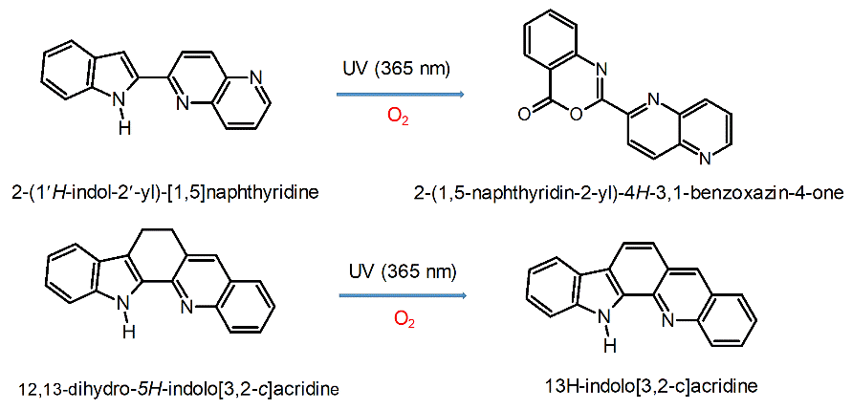

**Scheme 1. S**tructures of **IA**, **IN** and their main photoproducts.

References

1. B. Golec, K. Nawara, A. Gorski, R. P. Thummel, J. Herbich and J. Waluk, *Phys. Chem. Chem. Phys.*, (2018) DOI: 10.1039/c8cp00726h.

2. B. Golec, M. Kijak, V. Vetokhina, A. Gorski, R. P. Thummel, J. Herbich and J. Waluk, *J. Phys. Chem. B*, 119 (2015) 7283.

**Magnetic Circular Dichroism of *meso*-phenyl-substituted Pd-octaethylporphyrins**

**Aleksander Gorski1, Valery Knyukshto2, Eduard Zenkevich2, Alexander Starukhin2, Jędrzej Solarski1, Michał Kijak1**

*1**Institute of Physical Chemistry, Polish Academy of Sciences, Kasprzaka 44/52, 01-224 Warsaw, Poland,* [*agorski@ichf.edu.pl*](mailto:agorski@ichf.edu.pl)

*2B.I. Stepanov Institute of Physics, National Academy of Sciences of Belarus, Independence Av. 68, 220072, Minsk, Belarus*

The tetrapyrrolic compounds like porphyrin and its derivatives are relevant in biological processes including electron transfer, oxidation catalysis and photosynthesis. The ground state and the excited states geometries as well as spectral and photophysical properties of porphyrin derivatives are strongly depended on peripheral substituents and their mutual spatial distribution. Therefore, it is important to get information concerning the influence of increasing number of alkyl and aryl substituents in the inter-ring positions on geometry and electronic structure of tetrapyrrolic-based molecules.

|  |
| --- |
| C2H5  C2H5  C2H5  C2H5  C2H5  H5C2  H5C2  C2H5  N  N  N  N  **Pd** |
| PdOEP |
| *Fig. 1. Top, chemical structure of Pd-2,3,7,8,12,13,17,18-porphyrin. Bottom, MCD and absorption spectra.* |

Magnetic circular dichroism (MCD) is one of the powerful tools of investigation of excited states properties of organic molecules. The shape and sign of MCD spectra of porphyrin or its isomers (porphycene, etc) can be easily predicted theoretically even without engaging the time-consuming quantum-chemical calculations [1,2]. In this work, MCD studies were performed for a series of Pd-octaethylporphyrin (Pd-OEP) derivatives with different number of bulky *meso*-phenyl substituents (Fig. 1). In results, it was possible to separate and locate electronic transitions in the regions of Q and Soret bands for six different derivatives. Analysis of signs of B terms of the MCD spectra based on the perimeter model proposed by J. Michl [2] allows to assign Pd-OEP to positive hard chromophore. While with increasing of number of phenyl substituents, the behavior of MCD spectra points to changes of chromophores character toward soft chromophores. The proposed conclusion was confirmed by quantum chemical calculations and predicted differences in HOMO/LUMO energy splitting.

**Acknowledgment**

This work was supported by the European Union’s Horizon 2020 research and innovation programme under grant agreement No 645628.

**References**

1. Michl, J. Tetrahedron 1984, 40, 3845.
2. Waluk, J.; Michl, J. *J. Org. Chem.* 1991, 56, 2729.

**5-oxatruxene as a solid platform for future optoelectronics materials**

**Krzysztof Górski, Justyna Mech-Piskorz, Krzysztof Noworyta, Barbara Leśniewska, Oksana Pietraszkiewicz, Marek Pietraszkiewicz**

*Institute of Physical Chemistry, Polish Academy of Sciences, Kasprzaka 44/52, 01-224 Warsaw, Poland*

Popularity of truxenes falls on the 90-th of the last century. Till now modified truxene structures were used in photovoltaics as sensitizers or hole transporting material, in organic electronics, as fluorescence probes, in liquid crystals as skeleton of a structure, and finally in non-linear optics, especially in organic lasers. In many cases truxenes stand for scaffold, stable and compact, with convenient spots for modification. Optimization of energy of electronic levels seems to be the fundamental step in obtaining perfect OLED material. One of the possibilities for tuning energy levels in truxene based structures is incorporation of different length segmental branches like oligothiophenes. However, complicated and robust structure is not the key to obtain desirable compound. Simple modification of the truxene unit by incorporation of heteroatom in the cyclic scaffold gives surprising results. Attempts to synthesize triheterotruxenes succeeded in 1984. Acidic condensation of three identical subunits results in formation of trioxa-, trithia- and triazatruxenes. In our work, we synthesized and measured properties of 5-oxatruxene – representative compound of new class of truxene cores, which opens new possibilities in designing of optoelectronic materials.

**Photochemistry of indazole-3-carboxylic acid isolated in low-temperature matrices**

W. Gul, M. Pagacz-Kostrzewa, M. Wierzejewska

Faculty of Chemistry, University of Wrocław, Joliot-Curie 14, 50-383 Wrocław, Poland

The family of nitrogen-containing heterocycles, especially the structurally diverse derivatives of indazole (1*H*- and 2*H*- tautomers) arouse great interest because of wide variety of their biological activities. Among them are antitumor, antiHIV, antidepressant, antimicrobial, antifungal, anti-inflammatory and antioxidant properties.1 Indazole derivatives with carboxylic group are considered essential scaffold in medicinal chemistry. Recently indazole become of interest as a key moiety to synthesis of dyes2 and heterocyclic compounds with fluorescence switching properties based on the photochromism.3 Indazole has been studied extensively for its tautomerism, both computationally and experimentally,4 and it has been reported that the 1*H*-indazole is more stable than the 2*H*-tautomer in the gas phase and in aqueous solution. The literature reports also that the pathway of the photochemical transformations of indazole runs through rearrangements or the ring-opening reaction.5

The light–induced conformational changes and the photolysis behavior of the title compound, indazole-3-carboxylic acid(IND), have been studied by FTIR spectroscopy coupled with the matrix isolation technique. The analysis of the experimental results was supported by the DFT calculations carried out at the B3LYP/6-311++G(2d,2p) level.

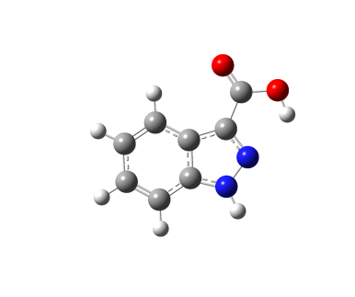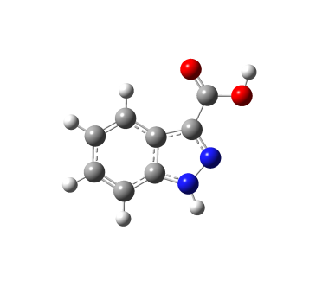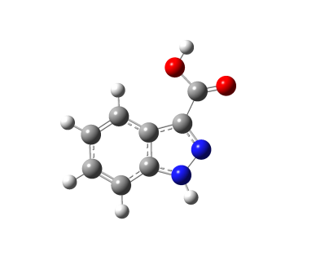The performed calculations revealed four stable IND structures for both 1*H*- and 2*H*- tautomers with the global minimum IND-1 stabilized by the OH…N intramolecular hydrogen bond. Analysis of FTIR spectra reveals the presence of three most stable IND-1, IND-2, and IND-3 species in agreement with the theoretically estimated population of these species. Exposition of the IND/N2 matrices to the UV and NIR radiation leads to the cis-trans isomerization of the carboxylic group between IND-1 into IND-2 as well as the backward reaction.

IND-1 IND-2 IND-3

_________________________________

A. Thangadurai, M. Minu, S. Wakode, S. Agrawal, B. Narasimhan. Med. Chem. Res. 21, (2012) 1509–1523

2 S. Poorhaji, M. Pordel, S. Ramezani. J. Mol. Str. 1119, (2016) 151-156

3 J. Liu, H. Liu, S. Pu. Tetrahedron Let. 56, (2015) 5223–5227

4 J. Catalan, J. Luis G. de Paz, J. Elguero J. Chem. Soc., Perkin Trans. 2, (1996) 57-60

5 J. P. Ferris, K. V. Prabhu, R. L. Strong J. Am. Chem. Soc. 14, (1975)

***From basic photophysics to the development of new chromophores:   
photochromism in hydroxycoumarin-based compounds***

**Agnieszka Jamrozik1, Joanna Buczyńska1, Barbara Leśniewska1, Kiran B Manjappa2, Mariusz Pietrzak1, Ding-Yah Yang2, and Jacek Waluk1**

*1 Department of Photochemistry and Spectroscopy, Institute of Physical Chemistry, Polish Academy of Sciences, Kasprzaka 44/52, 01-224 Warsaw, Poland, ajamrozik@ichf.edu.pl*

*2 Department of Chemistry, Tunghai University, 181, Taichung-Kang Rd. Sec.3, Taichung 407, Taiwan*

Large series of new hydroxycoumarin-based compounds were found to exhibit complex photochromic properties. We observed changes of their colour upon UV irradiation both in solution and in the solid state.

The electronic absorption and emission spectra were monitored in correlation with NMR and IR spectra in solvents of different polarities. Photochromism of crystals was investigated by X-ray diffractometry.

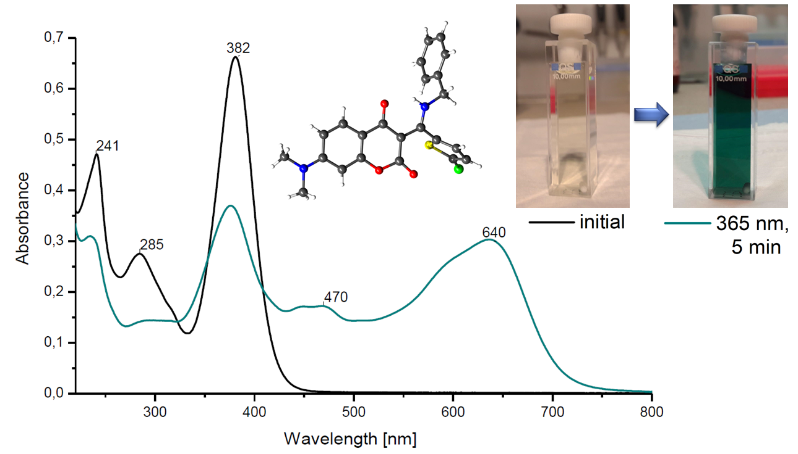

Fig. 1 Changes in UV-VIS absorption spectra in the solution state upon UV irradiation.

These experiments revealed a presence of several species in the photoreaction mixture exhibiting not only photochromism, but also thermochromic behaviour. Explanation of this fact may be production of various forms as a result of rotations of specific moieties, charge transfer phenomena in compounds bearing the dimethylamino group, as well as possibly excited-state intramolecular proton transfer (ESIPT).

We hope these studies might be beneficial to theoretical photophysics and lead to applications of the investigated compounds as new photochromic colorants or sensors.

**Photophysical and photochemical properties of push-pull dyes based on benzimidazole skeleton**

**Andrzej Wrzyszczyński, Beata Jędrzejewska**

UTP University of Science and Technology, Faculty of Chemical Technology and Engineering, Seminaryjna 3, 85-326 Bydgoszcz, Poland. email: beata@utp.edu.pl

Dyes with controllable and tunable fluorescence are desirable luminescent materials for optoelectronic devices, photoconductors, light emitting devices (LED), solid-state lasers, biochemical fluorescent technology and non-linear optics. Among them, compounds possessing electron-donating (D) and electron-accepting (A) groups on opposite sides of a π-conjugated linker are very important due to intramolecular charge transfer (ICT) [1-2]. Their photochemical and photophysical properties depend on the excited-state processes that occur after absorption of a photon (interaction with solvent molecules, rotation about single bonds, photoisomerisation etc.).

Photoisomerization is crucial process from practical point of view because, e.g. photoisomerizable molecules has been aimed at molecular devices, such as [molecular switches](https://en.wikipedia.org/wiki/Molecular_switch) [3], [molecular motors](https://en.wikipedia.org/wiki/Molecular_motor) [4], and [molecular electronics](https://en.wikipedia.org/wiki/Molecular_electronics), as well as at [pigments](https://en.wikipedia.org/wiki/Pigment) for [rewritable CDs](https://en.wikipedia.org/wiki/CD-RW), [DVDs](https://en.wikipedia.org/wiki/DVD-RW), and [3D optical data storage](https://en.wikipedia.org/wiki/3D_optical_data_storage) solutions. Thus, the knowledge about regular substituent effect on photoisomerization may be very helpful in design new structures.

We investigated push-pull dyes based on a benzimidazole skeleton which represent stilbene-like structure with two aromatic moieties and a vinylic CC double bond, offering the possibility of *trans*→*cis* isomerism. The analysis of the structure–property relationship of the dyes and essential aspects of the *trans*→*cis* photoisomerization are discussed [5,6].

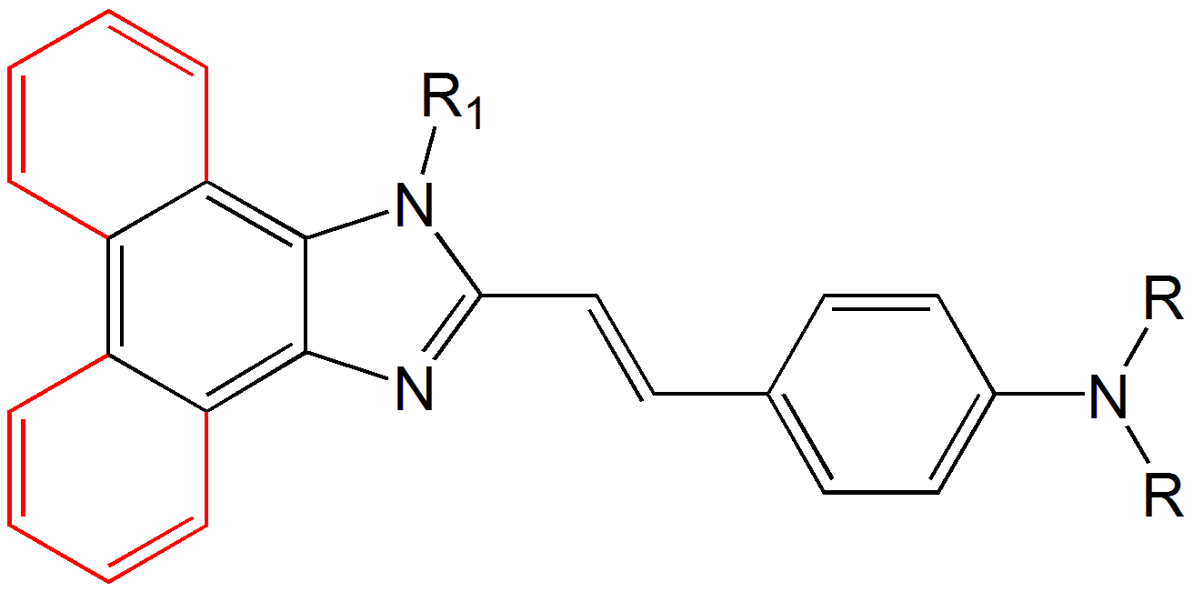

**Fig.1.** Push-pull dyes based on a benzimidazole skeleton for photoisomerization studies.

These dyes display high molar absorption coefficient, large Stokes’ shift, red shifted fluorescence upon increasing solvent polarity indicating intramolecular charge transfer characteristics and very efficient *trans*→*cis* photoisomerization [5,6].

[1] Wang C., Xu Q.W., Zhang W.N., Peng Q., Zhao C.H. *J Org Chem* **2015**, 80, 10914–10924.

[2] Raghuvanshi A., Jha A.K., Sharma A., Umar S., Mishra S., Kant R., Goel A. *Chem Eur J* **2017**, 23, 4527–4531.

[3] Mokdad A., Belof J., Yi S., Shuler S., McLaughlin M., Space B., Larsen R. [*J Phys Chem B*](https://en.wikipedia.org/wiki/Journal_of_Physical_Chemistry_B) **2008**, 112(36), 8310–8315.

[4] Vachon J. et al. [*Photochem Photobiol Sci*](https://en.wikipedia.org/wiki/Photochemical_and_Photobiological_Sciences) **2014**, 13(2), 241–246.

[5] Jędrzejewska B., Ośmiałowski B., Zaleśny R. *Photochem Photobiol Sci* **2016**, 15, 117–128.

[6] Krawczyk P., Jędrzejewska B., Pietrzak M., Janek T. *J Photochem Photobiol, B: Biol* **2016**, 164, 112–122 and **2017**, 166, 74–85.

**Tautomerism and Hydrogen Bonds in Parent, Unsubstituted Hemiporphycene and Oxahemiporphycenes**

**Michał Kijak1, Jakub Ostapko1, Anna Kelm1, Barbara Leśniewska1, Jacek Waluk1,2**

*1 Institute of Physical Chemistry, Polish Academy of Sciences, 01-224 Warsaw, Kasprzaka 44/52, Poland;*

*2 Faculty of Mathematics and Science, Cardinal Stefan Wyszyński University, Dewajtis 5, 01-815 Warsaw, Poland*

Among seven possible nitrogen-in constitutional isomers of porphyrin (PR) only one, porphycene (PC), has been obtained so far in the free, unsubstituted form. Herein, another isomer, parent hemiporphycene (HP), and its thorough structural, spectral, photophysical and theoretical characterization are discussed.

Hemiporphycene revealed its unique character with respect to the intramolecular hydrogen bond (HB) nature. We found, what seems to be an exception from the general rule, which is held also for differently substituted porphycenes [2], that the longer hydrogen bond is stronger than the shorter one. We claim that in such complex systems as porphyrinoids of low symmetry (e.g. hemiporphycene), hydrogen bond nature is governed by both, its length and the N-H···N angle.

To explore the geometrical (angle and distance) dependences on HB strength, we propose a model: monooxa-analogues of hemiporphycene, with one donating NH group and two nitrogen atoms being HB acceptors in its free-base state. Oxahemiporphycenes (OHP) may exist in different tautomeric forms, which makes them a promising model for intramolecular HB investigations.

Acid titration of 23-oxahemiporphycene and hemiporphycene monitored by UV-vis and emission spectroscopy allowed us to observe its singly and doubly protonated forms. The stabilization of singly-protonated form contrasts with protonated porphyrin, which rapidly accepts a second proton, forming dicationic structure [3].

scheme

**Acknowledgements**

This work was supported by the Polish National Science Centre (NCN) grant no. 2015/17/N/ST5/0281, by the European Union’s Horizon 2020 research and innovation programme under grant agreement No 645628, and the computing grant from the Interdisciplinary Centre for Mathematical and Computational Modeling.

[1] J. Ostapko et al., *Chem. Eur. J.*, *22*, **2016**, 17311

[2] M. J. Webb, N. Bampos, *Chem. Sci.*, *3*, **2012**, 2351

[3] P. Ciąćka et al., *J. Phys. Chem. B*, *119*, **2015**, 2292

**High Vibrational Overtone Excitation Induced**

**Isomerization of Glycolic Acid in Solid Argon**

Iwona Kosendiak1, Jussi Ahokas2, Justyna Krupa1, Jan Lundell2, Maria Wierzejewska1

*1Faculty of Chemistry, F.Joliot-Curie 14, 50-383 Wrocław, Uniwersity of Wrocław, Poland*

*2University of Jyväskylä, Department of Chemistry, FI-40014 Jyväskylä, Finland*

iwona.kosendiak@chem.uni.wroc.pl

High vibrational excitation induced photochemistry on the electronic ground state of glycolic acid is an interesting research subject from many points of view. Glycolic acid itself is widely used in various applications in chemical and medical industry and it is also found in atmosphere among the carboxylic acids in airborne aerosols1. Glycolic acid is the smallest  
α-hydroxycarboxylic acid containing two functional OH groups and is capable to form intra- and intermolecular hydrogen bonding. Two functional OH groups in the same molecule opens a possibility to selectively study the chemistry of glycolic acid induced by the high overtone

excitation of both the alcohol and the carboxyl OH groups. The cross-sections of the  
O-H stretching vibrational transitions are typically larger than C-H, S-H, and N-H vibrational

transitions, thus the high vibrational overtone excitation of molecules is possibly  
more efficiently generated via O-H vibrational overtone absorption. The generation of the high vibrational excitations of molecules on the ground electronic states by the direct absorption of photons gives an opportunity to gain information on intramolecular vibrational redistribution (IVR) processes. The IVR processes also play an important role in atmospheric chemistry and it has been suggested that the high overtone and combination mode absorption of sunlight might induce unimolecular chemical reactions on the ground electronic state of molecules in atmosphere in certain conditions.

The high overtone induced isomerization of glycolic acid in a low temperature argon matrix was investigated using Raman spectroscopy. The Raman spectrum of glycolic acid is presented and the spectral assignment is supported by vibrational anharmonic calculations. The high overtone excitation of the lowest energy conformer (SSC2,3) at 532 nm induced direct isomerization to higher energy conformers (GAC and AAT). Furthermore, upon excitation at 532 nm GAC and AAT isomerized back to SSC and photo-induced equilibrium was observed between the conformers. Kinetic model was used to describe the observed isomerization and isomerization rate constants were obtained. No experimental evidence of isomerization between GAC and AAT, nor other higher energy conformers were observed.

References

1. Havey, D.K. Feierabend, K.J. Takahashi, K. Skodje, R.T. Vaida, V. J. Phys. Chem. A. 110, (2006), 6439-64462.
2. Reva, I. Jarmelo, S. Łapiński, L. Fausto, R. Chemical Physics Letters 389, (2004), 68-74.
3. Reva, I. Jarmelo, S. Łapiński, L. Fausto, R. J. Phys. Chem. A. 108, (2004), 6982-6989.

*Acknowledgements:* The research was supported by the National Science Centre Project No. 2013/11/B/ST4/00500. A grant of computer time from the Wrocław Center for Networking and Supercomputing is gratefully acknowledged. The work was supported by Academy of Finland research project “Vibrational excitation induced chemistry” (Proj.No 286844).

**Fluorescence Spectroscopy Study of Cyclodextrin Inclusion Complexes with Bifunctional Heteroazaaromatic Molecules**

Małgorzata Koźbiała, Michał Gila, Alexander Kyrychenkob, Magdalena Ceborskaa

and Jacek Waluka

a Institute of Physical Chemistry, PAS, Kasprzaka 44/52, 01-224 Warsaw, Poland

b V.N. Karazin Kharkiv National University, Svobody Square, 4, Kharkiv, Ukraine

Heteroazaaromatic derivatives of indole and carbarbazole (**1**-**4)** are bifunctional compounds possessing two types of nitrogen binding sites, where one acts as hydrogen bond donor, while the second type as hydrogen bond acceptor in protic solvents.



The excited-state behavior of these compounds depends on the possibility of formation of cyclic and acyclic hydrogen bonds (HB) with solvent molecules. The formation of cyclic HB between presented compounds and alcohols molecules facilitates excited state proton transfer which is detected by the appearance of new low-energy fluorescence, red-shifted with respect to the “normal” band. However, the majority of water complexes are not prone to phototautomerization, but are deactivated via a process that is not efficient in non-hydrogen bonded chromophores.1,2 Aqueous solubility of studied compounds are very low (10-4 to 10-7 mol dm-3 in water at 25oC ).

The addition of cyclodextrins, cyclic oligosaccharides consisted of 6-8 α-D-glucopyranose units to aqueous solutions of compounds **1**-**4**, largely enhances their solubility due to inclusion complex formation between studied compound and cyclodextrin. The inclusion strongly changes fluorescence behavior of these compounds in comparison with pure water solution.

This work presents results of solubility and stationary and time-resolved fluorescence study of compounds **1**-**4** in aqueous solutions containing α -, β -, and γ-cyclodextrins. Significant enhancement of solubility was observed in solutions containing β -, and γ-cyclodextrin for all species under study, but spectral properties of compounds **1-4** in cyclodextrins solutions depended on complexed species and cyclodextrin cavity dimensions. A significant enhancement of fluorescence intensity was observed due to fact that cavity may restrict access of water molecules to the complexed guest. Additionally, molecular dynamics simulations for 1:1 complexes of studied compounds with cyclodextrins were carried out, which confirmed formation of stable inclusion complexes of compounds **1**-**4** with cyclodextrins, and showed potential architecture of obtained complexes.

1. A. Kyrychenko, J. Herbich, M. Izydorzak, F. Wu, R. P. Thummel, J. Waluk, J. Am. Chem. Soc. 1999, 121, 11179-11188

2. J. Waluk, Acc. Chem. Res. **2003,** 36, 832-838

Photochemistry of small compounds of atmospheric relevance.

Justyna Krupaa, Maria Wierzejewskaa, Iwona Kosendiaka

*a* *Faculty of Chemistry, F. Joliot-Curie 14, 50-383 Wrocław, University of Wrocław, Poland*Hydrogen peroxide (H2O2) is an important atmospheric species. It plays a significant role in the gas phase oxidation reactions and combustion processes in the Earth’s atmosphere. H2O2 has an important impact in the production and fate of hydroxyl and peroxyhydroxy radicals in the troposphere. In turn, isothiocyanic acid (HNCS) is well known as an interstellar molecule and it was detected almost 40 years ago in the rich molecular cloud of Sagittarius B2 (Sgr B2). Studies of the UV-induced photo-transformations of these small molecules contribute significantly to the knowledge of photochemical reactions taking place in the atmosphere and in the interstellar space.

In this contribution, we present new aspects of the UV decomposition of HNCS and H2O2 isolated in nitrogen matrices. The most spectacular result for the isothiocyanic acid is detection of the complex of HCN with atomic sulfur S...HCN. This is the first hydrogen-bonded complex formed with the participation of sulfur atom as a proton acceptor. The results of the extended theoretical calculations point out significance of dispersion contribution in the S...HCN interaction. The major photoproducts of the hydrogen peroxide were identified as nitrous oxide and N2O…H2O complex and free and complexed to N2O hydroxyl radicals. Except for the OH radicals all observed species are unique and characteristic for H2O2 photolysis in solid nitrogen.

**Acknowledgements**

The research was supported by the National Science Centre Project No. 2013/11/B/ST4/00500. A grant of computer time from the Wrocław Center for Networking and Supercomputing is gratefully acknowledged.

**References**

J.R. Durig, C. Zheng, H. Deeb, *J. Mol. Struct.* 784 (2006) 78.

M. Wierzejewska, J. Moc, *J. Phys. Chem. A*, 107 (2003) 11209.

R.P. Wayne, *Chemistry of Atmospheres*, Oxford University Press, 1991.

E. Catalano, R. Sanborn, *J. Chem. Phys.* 38 (1963) 2273.

J. Krupa, I. Kosendiak, M. Wierzejewska, *Phys. Chem. Chem. Phys.* 17 (2015) 22431.

J. Krupa, M. Wierzejewska, *J. Photochem. Photobiol. A* 330 (2016) 134.

**Photoinduced single crystal to single crystal transformation of coumarin derivative**

Barbara Leśniewska1, Agnieszka Jamrozik1, Kiran B. Manjappa2, Ding-Yah Yang2

and Jacek Waluk1

*email: blesniewska@ichf.edu.pl*

*1 Institute of Physical Chemistry Polish Academy of Sciences; Kasprzaka 44/52, 01-224 Warsaw, Poland*

*2Department of Chemistry, Tunghai University, 181, Taichung-Kang Rd. Sec.3, Taichung 407, Taiwan*

Coumarin derivatives which possess photochromic and thermochromic properties have been synthesized and examined. Several transition products are formed in the solution of studied compounds during the exposure to UV-Vis radiation. Determination of the structure of the product and the reaction kinetics is complex by the fact that both substrates and products absorb radiation in a similar range. In solution, as well as in the crystals (Fig. 1) of the tested materials the colour change is observed. In order to explain the occurring phenomena, UV-Vis absorption and emission spectroscopy, infrared spectroscopy, NMR and X-ray crystallography research was carried out. These studies may explain a complex mechanism that may be important for basic studies and also for potential applications.

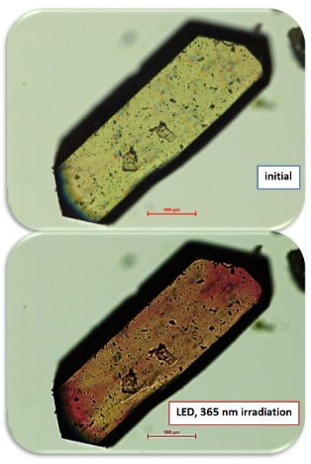

Fig. 1. Color change in the crystal after UV irradiation and the structure of the irradiated compound.

[1] P.-Y. Kuo, R.-R. Chuang, D.-Y. Yang, *Mol Divers* 2009, **13**, 253-260.

**Synthesis and photophysical properties of selected**

**porphycene derivatives substituted at *meso* positions**

Natalia Masiera,1 Arkadiusz Listkowski,1,2 Michał Kijak,1 Jacek Waluk1,2

1 Institute of Physical Chemistry, Polish Academy of Sciences, Kasprzaka 44,01-224 Warsaw

nmasiera@ichf.edu.pl

2 Faculty of Mathematics and Natural Sciences, College of Science, Cardinal Stefan Wyszyński University, Dewajtis 5, 01-815 Warsaw

Due to their biochemical and optical properties, derivatives of porphycene are very interesting objects of studies. Especially relevant are the *meso*-substituted compounds of this group: It was reported that 9,10,19,20-tetraalkylporphycenes may reveal different tautomeric forms: *cis* and *trans*. Tautomerization involving hydrogen transfer has been observed in solutions of the compounds in organic solvents [1].

The aim of the present study was to understand  
the relationship between the structure and photophysical properties of the porphycene derivatives substituted at the *meso* positions with aryl groups. The investigated compounds are presented in Fig. 1. The studies included the synthesis of the properly substituted porphycenes via McMurry reaction, determination of molar absorption coefficients and quantum yields, analysis of absorption and fluorescence spectra, estimation of the kinetic parameters of fluorescence decay, and quantum-chemical calculations. Fig. 1. Structures of the studied compounds

Time-correlated single photon counting experiments showed mono-exponential decay of fluorescence of **1** and **2** in both polar and nonpolar solvents. The values of time constants of fluorescence decay and fluorescence quantum yields determined for **1** were of the order expected for porphycenes in organic solvents. An interesting variation was observed for compound **2**. Fluorescence decays shorten drastically with respect to **1**, and the quantum yields of fluorescence of the order of 1% indicate the existence of a rapid S1 deactivation channel, which was confirmed in a range of different solvents. Fluorescence decay of **3** is mono-exponential only in the case of a nonpolar solvent, whereas in polar environment the compound reveals double-exponential kinetics of singlet excited state decay. This suggests the occurrence of two different forms of **3**, with the molar ratio dependent on the solvent, which is also confirmed by the fluorescence quantum yields measurements. Moreover, the analysis of the collected data shows that the lifetime of one form is three times shorter than that of the other. The experimental findings will be correlated with the results of quantum-chemical calculations.

As a part of this program some other porphycenes were prepared recently via McMurry cross-coupling of the proper bipyrrole derivatives: 9,20-bis(9-antracenyl)porphycene as well as 9,20-dicyclohexylporphycene. Unfortunately, synthesis of the *meso*-tetrasubstituted analogues of these compounds failed, probably due to the sterical hindrance of the substituents.

[1] Gil M., Dobkowski J., Wiosna-Sałyga G., Urbańska N., Fita P., Radzewicz C. Pietraszkiewicz M., Borowicz P., Marks D., Glasbeek M., Waluk J., *J. Am. Chem. Soc.* **2010**, *132*, 13472.

**Vertically oriented TiO2 nanotubes modified by iron: a useful material for pollutant degradation under flow conditions**

Paweł Mazierskia, Joanna Nadolnaa and Adriana Zaleska-Medynskaa

*aDepartment of Environmental Technology, Faculty of Chemistry, University of Gdansk,* *Wita Stwosza 63, 80-308 Gdansk, Poland*

In recent years, the rapid development of heterogeneus photocatalysis in various fields is particularly noticeable. In particular, TiO2-based photocatalysis was applied in air, water and wastewater treatments; hydrogen and oxygen production by water splitting; inactivation of microorganisms; dye-sensitized solar cells; CO2 conversion into useful hydrocarbons and selective organic transformations and are the most investigated [1][2]. Here, we present an original approach (anodization of Ti-Fe alloys) to obtain ordered TiO2 nanotube arrays modified by iron species (displayed in Figure 1a-i) exhibited enhanced light absorption capacity and facilitated the photogenerated charges separation/transfer and therefore a significantly improved photocatalytic activity under flow conditions.

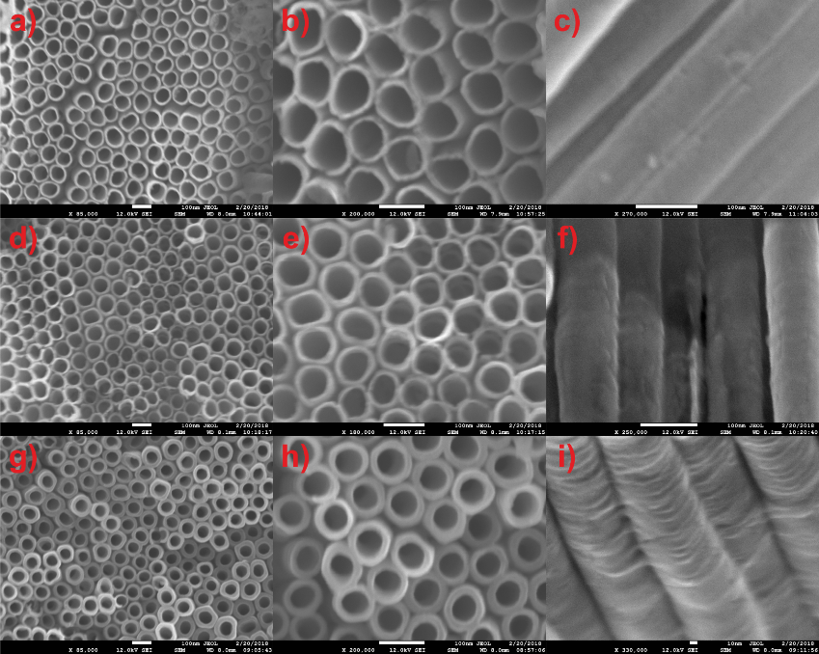

**Figure 1.** Surface and cross-sectional morphology of modified TiO2 NTs

**Acknowledgements**

This research was financially supported by the Polish National Science Center grant No. 2014/15/B/ST5/00098 entitled “Ordered TiO2/MxOy nanostructures obtained by electrochemical method”.

**References**

[1] Y. Ma, X.L. Wang, Y.S. Jia, X.B. Chen, H.X. Han, C. Li, Titanium Dioxide-Based Nanomaterials for Photocatalytic Fuel Generations, Chem. Rev. 114 (2014) 9987–10043. doi:10.1021/cr500008u.

[2] H. Kisch, Semiconductor Photocatalysis for Chemoselective Radical Coupling Reactions, (2017). doi:10.1021/acs.accounts.7b00023.

**Porphycenes as photodynamic therapy agents**

**Natalia Masiera1, Karina Kwapiszewska1, Agnieszka Bojarska2, Iwona Gawryszewska2, Jacek Waluk1**

*1Institute of Physical Chemistry, Polish Academy of Sciences, 44/52 Kasprzaka, 01-224 Warsaw, Poland*

*2National Medicines Institute, 30/34 Chelmska, 00-725, Warsaw Poland*

Photodynamic therapy (PDT) is the method of treatment that can be applied in the range of medical conditions, from cancer to microbial infections. It involves combined use of two, otherwise neutral, factors: light and photosensitizer (PS). Their interaction leads to the generation of molecular oxygen in its singlet state, which creates a potent oxidant inducing the cell death in a targeted tissue or microorganism.

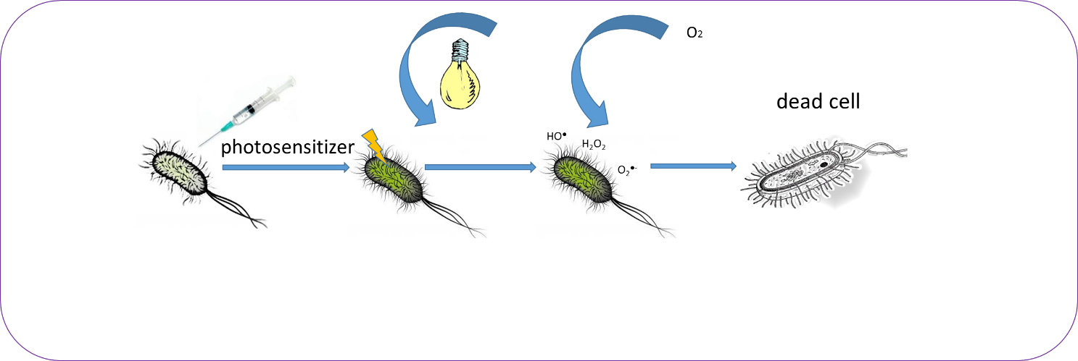

Porphycenes are studied as potential candidates for second generation of photosensitizers. With the high absorption coefficients in the red part of spectrum and despite of the moderate yields of singlet oxygen formation they were proven to exhibit significant phototoxic effect against cancer cells *in vivo* [1]

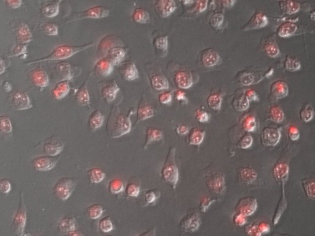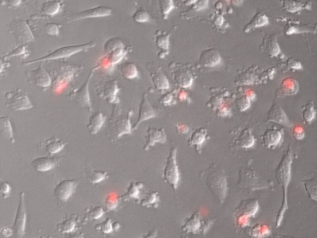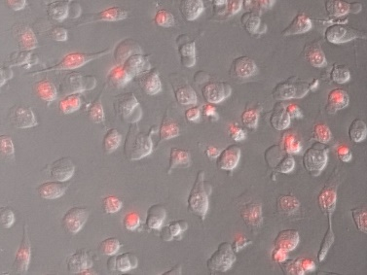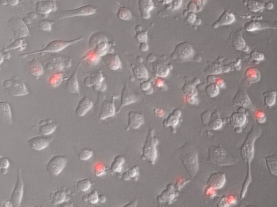

20 min

1 min

10 min

5 min

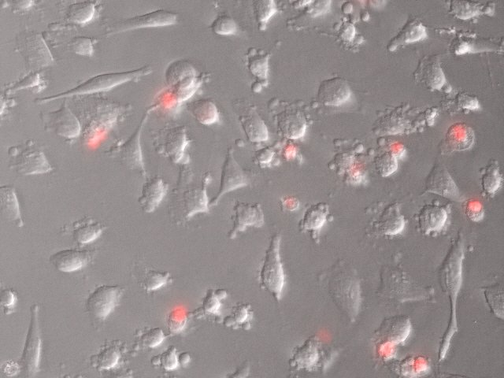

5 min

1 min

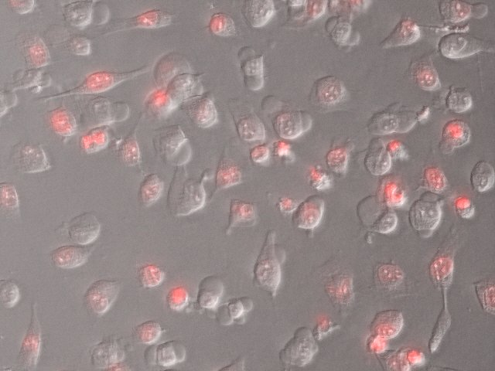HeLa cells in different times after irradiation with porphycene. Red dye indicates dead cells.

10 min

5 min

1 min

Our studies proved that the selected porphycenes exhibit very good photosensitizing properties under *in vitro* conditions against both cancer cells and Gram-positive bacteria. [2] We focus on uncharged porphycenes, including the parent, unsubstituted compound. Pluronic F-127 micelles are used to deliver the molecules into the HeLa cancer cells and several *cocci* bacterial strains. Three of the studied photosensitizers turned out to photoinactivate bacteria and to induce lethal mechanism in cancers cells. Only one compound has shown no effect against both kinds of pathogenes.

[1] J. C. Stockert, M. Cañete, A. Juarranz, A. Villanueva, R. W. Horobin, J. I. Borrell, J. Teixidó, S. Nonell, *Curr. Med. Chem,* (2007) 14, 997.

[2] N. Masiera, A. Bojarska, I. Gawryszewska, E. Sadowy, W. Hryniewicz, and J. Waluk, *J. Photochem. Photobiol. B Biol.*, (2017) 174, 84–89.

**Controlling the optical properties of methyl salicylate by strong light-matter coupling**

**Wassie Mersha1, Lukasz Piatkowski1 and Jacek Waluk1,2**

**1Institute of Physical Chemistry, Polish Academy of Sciences, Kasprzaka 44/52, 01-224 Warsaw, Poland.**

**2Faculty of Mathematics and Science, Cardinal Stefan Wyszyński University, Dewajtis 5, 01-815 Warsaw, Poland.**

When the coherent energy exchange between a molecular transition and a cavity mode becomes faster than any competing dissipation process, the so-called strong coupling of light and matter occurs. Strong coupling leads to the formation of two hybridized light-matter polaritonic states, P+ and P-, separated by a Rabi splitting. These half-light half-matter states have interesting optical, electronic and material properties possessed neither by the original molecule nor the optical mode. [1]. Hence, currently, we are developing a method to investigate the effects of this phenomenon on spectral and photophysical properties of organic molecules, using methyl salicylate (MS) as a model compound.

So far, different vibrational modes of MS, including the broad O-H vibration, have been successfully coupled with the cavity mode. In addition, we have been investigating the influence of this coupling on the fluorescence emission and Raman scattering properties of MS. The future work will focus on preparation and characterization of nanofluidic cavities to modulate proton transfer reactions by electronic light−matter strong coupling.

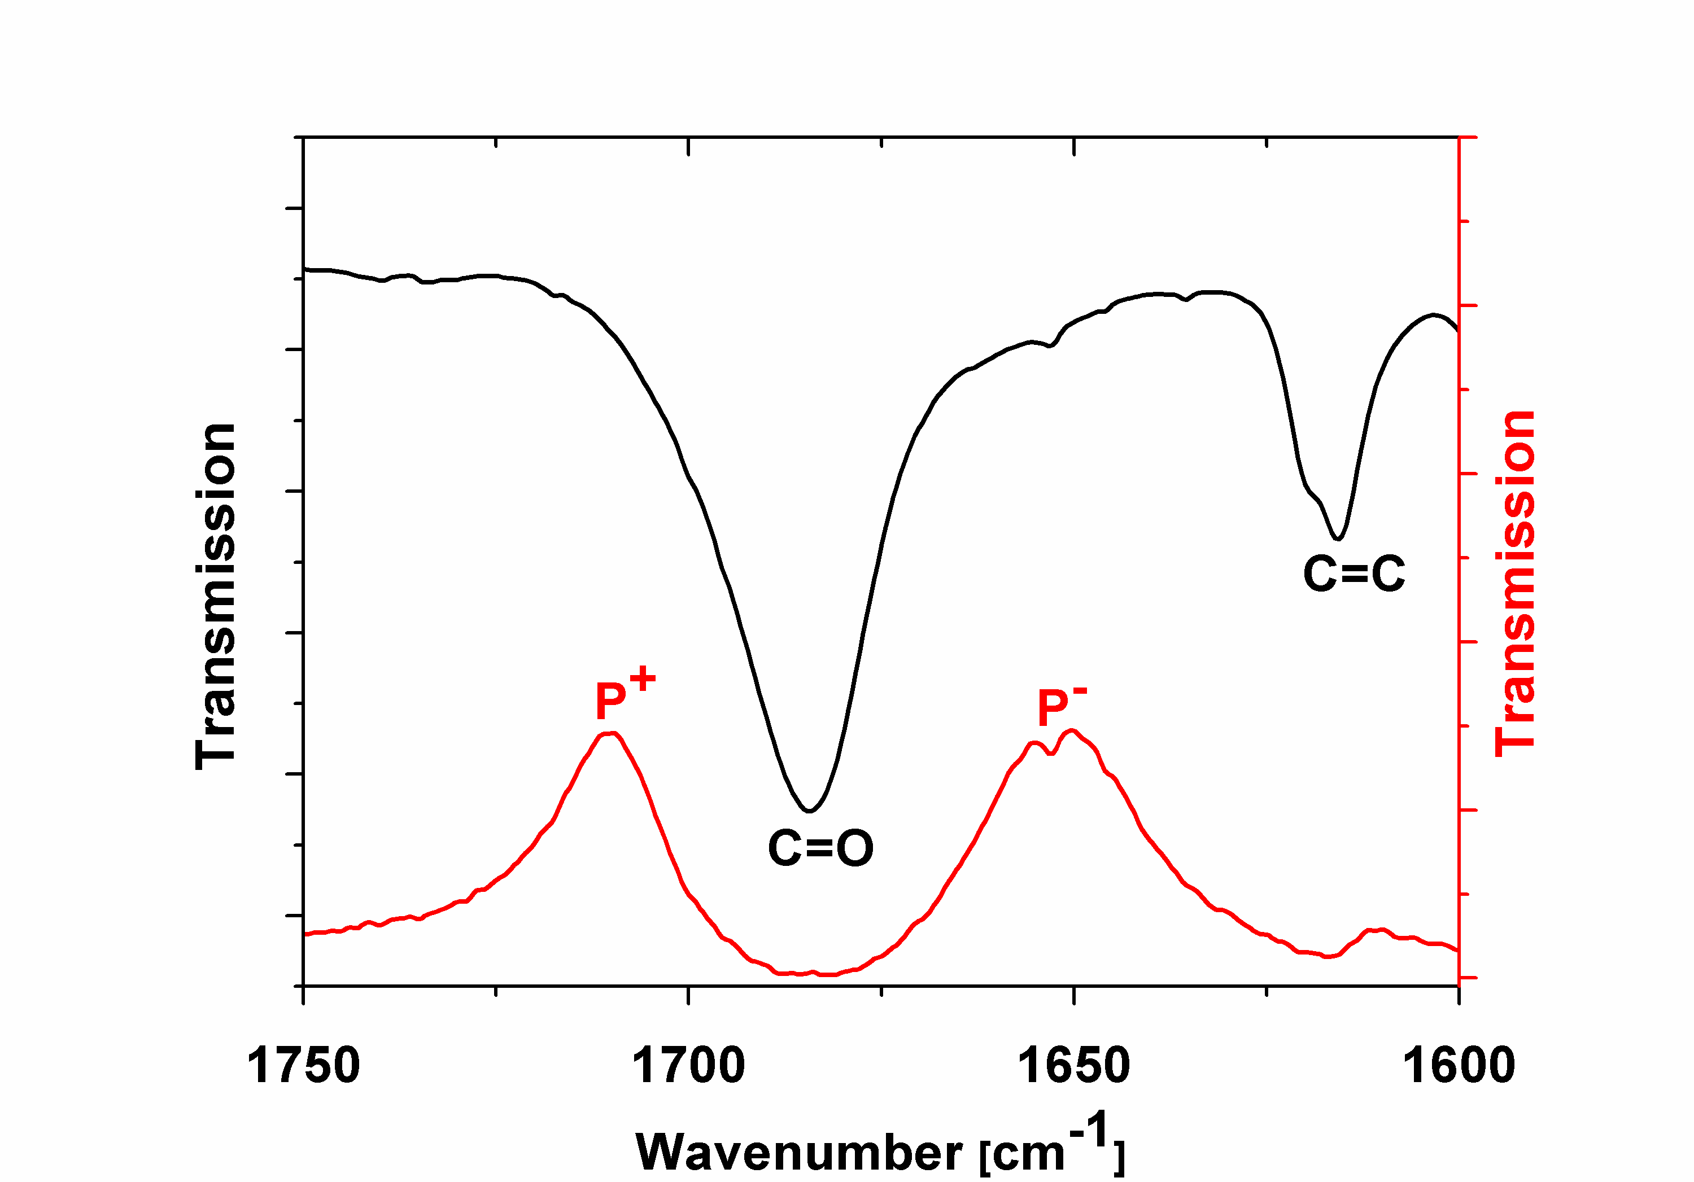

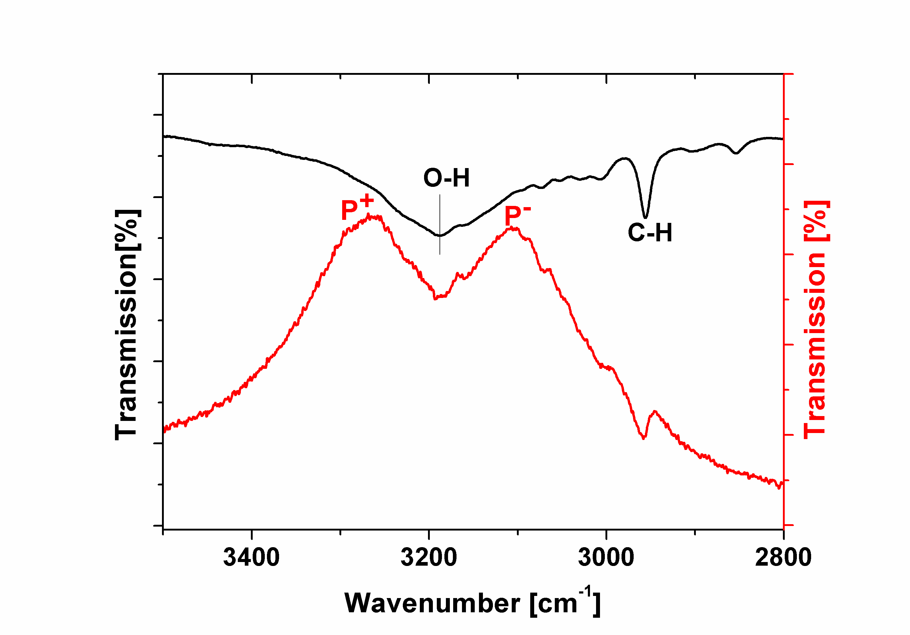

a)

b)

Figure 1. FTIR spectra of MS (black curves) and MS filled microcavity (red curves) when the cavity mode was resonant with: a) the C=O vibration, b) the O-H vibration.

1. Ebbesen, T. W. (2016) Hybrid Light-Matter States in a Molecular and Material Science Perspective. *Accounts of Chemical Research*, 49 (11), 2403–2412.

**Spectroscopic characterization of active substance transport in polyurethane nanocomposite hydrogels**

Marta Miotke1, Justyna Strankowska1, Jerzy Kwela1, Marek Józefowicz1, Michał Strankowski2

*1Institute of Experimental Physics, Faculty of Mathematics, Physics and Informatics, University of Gdańsk, Poland*

*2Department of Polymer Technology, Faculty of Chemistry, Gdańsk University of Technology, Poland*

1marta.miotke@phdstud.ug.edu.pl

The main purpose of our research is to achieved material with predetermined and well defined hardness, elasticity, and with appropriate swelling and release profiles. In previous papers we described method of synthesis and studies of basic mechanical properties (using DMA technique) and we examined structure of polyurethane nanocomposite by means of X­ray diffraction. The naproxen sodium an paracetamol – commonly used inflammatory drugs, were chosen as an active substances potentially released from biomaterial. Before molecule reaches the target receptor, it changes the environment from polar protic – body fluids, to nonpolar cavity receptor. Understanding possible interaction between drug and solvent molecules in the ground and/or excited states was one of the main aim of this work. To achieve this goal, steady­state absorption and fluorescence spectra of naproxen in solvents of different polarities were registered. In addition, using steady­state spectroscopy methods, positive influence of presence of nanoparticles (organofilized montmorillonite – Cloisite30B) in polymer matrix was observed. Analysis of release active substance from polyurethane matrix were determined basing on light absorption spectra. The concentration of drug molecule was registered as a function of time. The most common mechanism of drug release from hydrogels is passive diffusion. In our case this process is guaranteed by presence of nanoparticles. Obtained results confirmed the high possibilities of polyurethane nanocomposite hydrogels as a new type of wound dressing material with the ability to release of drugs.

**Steel mesh wire as a thermally resistant SERS platform**

**K. Nicińskia, T. Szymborskia,b, E. Witkowskaa, Z. Majkaa, T. Krehlika,   
T. Deskura, K. Winklera and A. Kamińskaa**

*aInstitute of Physical Chemistry, Polish Academy of Sciences, Kasprzaka 44/52,*

*01-224 Warsaw, knicinski@ichf.edu.pl*

*bSoft Materials Laboratory, Institute of Materials, Ecole Polytechnique Fédérale de Lausanne, 1015 Lausanne, Switzerland*

The detection and identification of minute amounts of organic and biological samples is a vital problem in many chemical, biomedical and forensic laboratories, as well as industrial research centers. Surface-enhanced Raman spectroscopy (SERS) has proven its usefulness in these areas1,2, however there is still a need for cheap, stable platforms with high enhanced factor (EF). In this poster we present novel type of SERS platform, based on stainless steel wire mesh (SSWM) covered with thin layer of SERS-active metal, i.e. silver. The stainless steel mesh wire is a cheap and versatile substrate for SERS platforms. SSWM consists of multiple steel wires with diameter of ten of micrometers, what gives periodical structure and high stiffness. Moreover, stainless steel provides great resistance towards organic and inorganic solvents and provides excellent heat dissipation. Continuous irradiation of the laser beam over the SERS substrate can be a source of significant increase in the local temperature of metallic nanostructures, what can lead to thermal degradation or fragmentation of the analyte. Decomposition or fragmentation of the analyte may lead to broadening and reduction of the intensity of observed spectral bands, thus to misinterpretation of analytical data. The developed substrates termed Ag/SSWM, exhibit high sensitivity to *p*-mercaptobenzoic acid (*p-*MBA) at a low concentration of 10-6 M and the enhancement factor of over 106 has been calculated. Designed substrates allow the specific detection and differentiation between Gram-positive and Gram-negative bacterial species: *Escherichia coli* and *Bacillus subtilis* in label-free and reproducible manner. This approach overcomes the limitations associated with photo-and thermal degradation of sensitive and week scattered materials. Consequently, distinctive spectral features provide insight into chemical and biological information of analyzed samples at high sensitivity and selectivity.

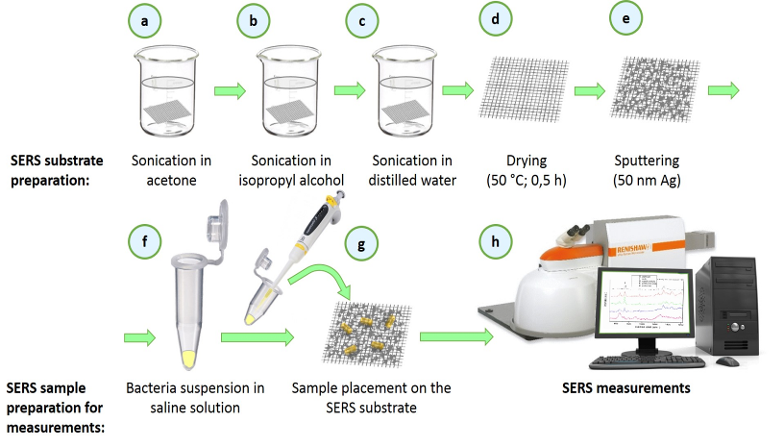**Figure 1.** Scheme of preparation of SERS substrate and sample deposition and measurement. Main steps involve cleaning (a-c), drying (d), and sputtering of thin layer of silver (e). Then the bacteria are deposited on SERS-platform (f-g) and finally the measurement takes place (h).

The authors would like to acknowledge the support from Foundation for Polish Science under grant Team Tech/2017-4/23.

**Synthesis, spectroscopy, photophysics, and molecular structure of 23-oxahemiporphycene and 21-oxacorrole-5-carbaldehyde**

Jakub Ostapko1*, Anna Kelm1, Michał Kijak1, Barbara Leśniewska1, Jacek Waluk1,2

1*Institute of Physical Chemistry, Polish Academy of Sciences, 01-224 Warsaw, Kasprzaka 44/52, Poland;*

*2Faculty of Mathematics and Science, Cardinal Stefan Wyszyński University, Dewajtis 5, 01-815 Warsaw, Poland*

*jostapko@ichf.edu.pl

Oxa-analogues of porphyrinoids are derived from the parent structures by formal replacement of one of nitrogen atoms by an oxygen atom. The single nitrogen-oxygen substitution influences the macrocyle properties, such as the NH position with respect to the parent tautomeric form or the formal charge of the macrocyclic ligand. Moreover, the structure may be destabilized by removing one of the two intramolecular hydrogen bonds. All of these changes have crucial impact on the interactions of the macrocycle with cationic partners. For instance, stabilization of lower oxidation states of metals by oxaporphyrin ligands have been reported in the literature.[1,2]

To investigate the interactions of an oxa-porphyrinoid **low symmetry** ligand with cations (metal or hydrogen) we propose a set of oxahemiporphycenes, derived from hemiporphycene. Here we present the synthesis of **23-oxahemiporphycene** **10**, one of the four possible structural isomers.

**23-oxahemiporphycene** formation under McMurry reaction conditions is surprisingly accompanied by formation of a formyl derivative of **oxacorrole** **11**. The mechanism of the formation of **11** relying on pinacol rearrangement of titanium pinacolate under McMurry reaction is proposed.

The different nature of interaction of **10** with organic acids is manifested by **unusual crystal packing** of the protonated form of 23-oxahemiporphycene **10·TFA**, which exhibits a π-π stacked column alignment of positively charged macrocycle units. The positively charged columns are separated from each other by TFA anions. Such arrangement is completely different from the structures of known porphyrin-acid complexes, stabilized by intermolecular hydrogens bonds.[3,4]

The **impact of the hemiporphycene low symmetry** is also manifested by different photophysical response to oxygen introduction. Whereas in the case of a symmetrical system the introduction of oxygen does not influence the photophysics significantly, in the case of hemiporphycene a drop of the fluorescence quantum yield is observed.

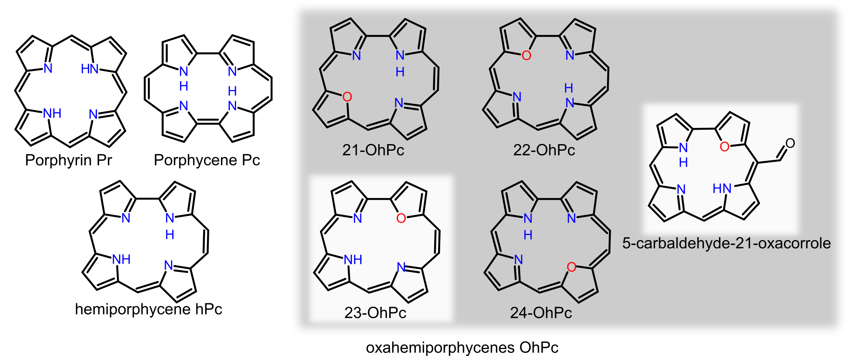

Hemiporphycene and its oxa-analogues.

This work was supported by the Polish National Science Centre (NCN) grant no. 2015/17/N/ST5/0281

[1] P. J. Chmielewski, L. Latos-Grażyński, M. M. Olmstead, A. L. Balch, *Chem. Eur. J.* **1997**, *3*, 268–278.

[2] E. Pacholska, P. J. Chmielewski, L. Latos-Grażyński, *Inorg. Chim. Acta* **1998**, *273*, 184–190.

[3] M. J. Webb, N. Bampos, *Chem. Sci*., **2012**, 3, 2351-2366

[4] S. Juillard, Y. Ferrand, G. Simonneaux, L. Toupet, *Tetrahedron* **2005**, *61*, 3489–3495

Photoinduced transformations of 1,2,4-triazole derivatives isolated in cryogenic matrices

M. Pagacz-Kostrzewa*a*, M. Sałdyka*a*, M. Wierzejewska*a*, D. Khomenko*b*, R. Doroschuk*b*

*aFaculty of Chemistry, Joliot-Curie 14, 50-383 Wrocław, University of Wrocław, Poland*

*bDepartment of Chemistry, Taras Shevchenko National University of Kyiv, Volodymyrska Street, 64/13, Kyiv 01601, Ukraine*

Triazole derivatives, especially connected to a six-membered ring, possess a great importance in medicinal chemistry and can be used for the synthesis of numerous heterocyclic compounds with different biological activities. They have different pharmacological actions such as antiviral, antibacterial, antifungal, antituberculosis and many others. They are also very stimulating heterocycles from an academic viewpoint due to their tautomeric and conformational properties and very interesting photochemistry.[1-4]

The conformational/tautomeric properties and the photolysis behavior of the 2-(1,2,4-triazolyl)phenol (TRP) were studied in argon and nitrogen matrices by infrared spectroscopy. Analysis of the experimental results was supported by extensive theoretical calculations carried out at the B3LYP/6-311++G(2d,2p) level of approximation. Out of the forty five TRP minima located on the potential energy surface, eight species are characterized by the presence of the intramolecular hydrogen bond formed between O-H group and one of the nitrogen atoms of the triazole ring. The three most stable of them were identified in the experimental TRP/Ar and TRP/N2 spectra: 2-(1*H*-1,2,4-triazol-5-yl)phenol (2-TRP1) and two conformers of 2-(1*H*-1,2,4-triazol-3-yl)phenol (1-TRP1 and 1-TRP2). The theoretically predicted population of TRP isomers at the sublimation temperature (*ca*. 373 K) equals 83.7, 10.3 and 6.0 %, for 2-TRP1, 1-TRP1 and 1-TRP2, respectively, while other isomers have a negligible population.

UV irradiation of the TRP isolated in low-temperature matrices induced two different photochemical processes occurring at different rates: isomerization related to the hydrogen atom transfer between different nitrogen atoms within the ring and photochemical fragmentation. Exposing TRP/Ar and TRP/N2 matrices to the monochromatic radiation of the 320 nm wavelength led to the 2-TRP1-TRP transformation (Ar matrix) and to the triazole ring cleavage (Ar and N2 matrices).

**Acknowledgment**

The research was supported by the National Science Centre Project No. 2014/13/D/ST4/01741. A grant of computer time from the Wrocław Center for Networking and Supercomputing is gratefully acknowledged.

**References**

[1] M. Pagacz-Kostrzewa, A. Bil, M. Wierzejewska, J. Photochem. Photobiol. A: Chemistry 335 (2017) 124.

[2] M. Pagacz-Kostrzewa, M. Sałdyka, M. Wierzejewska, D. Khomenko, R. Doroschuk, Chem. Phys. Lett. 657 (2016) 156.

[3] M. Pagacz-Kostrzewa, I. D. Reva, R. Bronisz, B. M. Giuliano, R. Fausto, M. Wierzejewska, J. Phys. Chem. A 15 (2011) 5693.

[4] M. Pagacz-Kostrzewa, R. Bronisz, M. Wierzejewska, Chem. Phys. Lett. 473 (2009) 238.

**Charge transport in perovskite solar cells**

Katarzyna Pydzińskaa, Jerzy Karolczaka,b and Marcin Ziółeka.

*a Faculty of Physics, b Centre of Ultrafast Laser Spectroscopy,   
Adam Mickiewicz University, Umultowska 85, 61-614 Poznań, Poland*

*e-mail:* *katarzyna.pydzinska@amu.edu.pl*

Perovskite solar cells (PSC) are one of the most promising devices which reached certificated efficiency equal to 22.7% in 2017. Outstanding tunable optoelectronic properties are obtained thanks to perovskite structure, sensitized with mixture of several ions e.g. FA (formamidinium), MA (methylamonium), Cs, Pb, Rb, I, Br [1]. The most common perovskite structure is MAPbI3. After a photon absorption, an electron is injected into electron transporting material (ETM), usually titanium oxide layer, a hole is transferred into hole transporting material (HTM), often spiro-MeOTAD.

Knowledge about charge transport into this system is one of the fundamental parts in the research. Employment of ultrafast spectroscopy allows researchers to determine behavior of the charge transport [2].

Despite the fact that PSCs have been being developed for several years, structure of the band gap is still under debate. Results of influence of different synthesis protocols of perovskite on femtosecond transient absorption features will be presented. Substitution of precursor ratio from stochiometric to non-stochiometric lead to change of transient band-edge signal from derivative-like bandgap shift to typical negative bleach [3].

**Acknowledgements**

The study was supported by National Science Centre under project 2016/23/N/ST5/00070.

**References**

[1] J.P. Correa-Baena, A. Abate, M. Saliba, W. Tress, T.J. Jacobsson, M. Gratzel, A. Hagfeldt, Energy Environ. Sci., 2017, 10, 710-727

[2] K. Pydzińska, J. Karolczak, I. Kosta, R. Tena-Zaera, A. Todinova, J. Idigoras, J.A. Anta, M. Ziółek, ChemSusChem, 2016, 9, 13, 1647-59

[3] K. Pydzińska, J. Karolczak, M. Szafrański, M. Ziółek, ACS Advances, 2018, 8, 6479

Modeling vibrational excitation in porphycene by symmetric and asymmetric mode couplings with the reaction path

*Tomasz Roliński and Jacek Waluk*

Institute of Physical Chemistry, Polish Academy of Sciences,

Kasprzaka 44/52, 01-224 Warsaw, Poland

It is well known that switching between two nuclear configurations can be observed in isolated porphycene at low temperatures. This switching leads to an isolated doublet of peaks in laser induced fluorescence (LIF) and single vibronic level dispersed fluorescence (SVLF) spectra [*]. The zero-point energy of the molecule is lower than the energy of the molecule at the saddle point configuration, which means that at low temperatures tunneling between configurations takes place. The rate of tunneling is proportional to the difference in energies (splitting) between doublet states, which equals 4.4 cm-1 for the two equivalent ground *trans* configurations characterized by the two protons in the inner cavity on both sides of the dividing plane perpendicular to the molecule and passing through the two protons at the saddle point configuration of highest symmetry. This rate of tunneling can be modified by excitation of some low frequency vibrational modes. There are two totally symmetric modes that are of particular interest: 2Ag mode (180 cm-1 ), which strongly promotes tunneling, and 1Ag mode (145 cm-1 ), which strongly suppresses tunneling, at least for the fundamental excitation. We have made an attempt at defining 3D quantum model that reconstructs the experimentally obtained energy levels and, consequently, the splittings for vibrational excitation of the modes.

[*] E. T. Mengesha, J Sepioł, P Borowicz, and J Waluk, Vibrations of porphycene in the S0 and S1 electronic states: Single vibronic level dispersed fluorescence study in a supersonic jet. J. Chem. Phys. **138**, 174201 (2013).

**Application of optical methods for screening of protein ligand interactions.**

Anna Szymaniec1, Ewa Bugajska1, Kinga Mieczkowska1, Sławomir Kasperowicz1,2, Jarosław Poznański1

*1 Institute of Biochemistry and Biophysics Polish Academy of Sciences, Depatment of Biophysics, Pawińskiego 5A, 02-106 Warsaw, Poland*

*2 Warsaw University of Technology, Faculty of Chemistry, Noakowskiego 3, 00-664 Warszawa, Poland*

Understanding the ligand binding mechanism is crucial in many fields, including a broad area of practical applications, for example in drug design. Protein kinases states the attractive biomolecular target because of their participation in diverse fundamental cellular processes controlled via phosphorylation of other proteins, which is involved in regulation of so crucial processes as cell growth or death. It has been found that abnormally active protein kinase CK2 may be responsible for uncontrolled cell proliferation. Its increased levels were also reported for hippocampus and temporal cortex of Alzheimer disease patients. Halogenated benzotriazole derivatives are selective ATP-competitive inhibitors of kinase CK2. Their inhibitory activity can be assessed by overall free energy of protein-ligand binding process, which can be decomposed into enthalpic contribution of electrostatic interactions, such as the energy of halogen/hydrogen bonds and mainly entropic hydrophobic interactions.

Thermal shift assay was used to measure the interactions of series of brominated and chlorinated ligands with the conserved ATP binding site of the catalytic subunit of human protein kinase CK2. Changes in the temperature of protein denaturation was found consisted with ligand hydrophobicity estimated semi-empirically from densimetric measurements, by calculation of differences observed between experimentally and theoretically determined volume of a single solute molecule. This parameter (beta) can be interpreted as a measure of the free energy of solvation of ligands in the absence of the protein. Correlation observed for thermodynamic and densymetric parameters supports our hypothesis that the hydrophobic interactions are the main driving force in the binding of halogenated ligands. In parallel, we have calculated basic physicochemical properties of studied ligands that are routinely determined upon early steps of drug design procedure. All of them were consistent with our experimental data. The presented results supports the statement that semi-experimental beta parameter could be also found useful in early drug design approach.

This work was supported by NCN grant 2015/19/B/ST4/02156.The equipment was sponsored in part by Centre for Preclinical Research and Technology (CePT).

**TAUTOMERIZATION AND ROTAMERIZATION OF 2-(2****ʹ-PYRIDYL)PYRROLE AND ITS DERIVATIVES**

Witold Wałecki1, Michał Kijak1, 2, Jerzy Herbich1, 2, Jacek Waluk1, 2,

*1 Institute of Physical Chemistry, Polish Academy of Sciences, Kasprzaka 44/52, 01-224 Warsaw, Poland*

*2 Faculty of Mathematics and Science, Cardinal Stefan Wyszynski University, Dewajtis 5, 01-815 Warsaw, Poland*

Tautomerization and rotamerization belong to the most often occurring types of isomerization within one molecule. These two processes have been observed in the case of 2-(2ʹ-pyridyl)pyrrole (**PP**, ***Fig.1.***) [1, 2]. Formation of intermolecular hydrogen bonds involving molecule(s) of a protic solvent and their influence on the equilibria between different isomers have been studied both, spectrally and computationally.

In this work, we investigate formylic derivatives of **PP** (Fig. 1b-c). UV-VIS absorption and fluorescence measurements for respective structures (***Fig.1.a***) have been carried out in solvents of various polarity and viscosity (acetonitrile, *n*-hexane, propanol, methanol, and tetrahydrofuran). Due to the fact that **PP** and its derivatives can be present in different rotameric structures, they will certainly have proclivity to create hydrogen bonds of different strength with solvent molecules. Additionally, the presence of formylic groups in the case of structures ***(b)*** and ***(c)*** introduces the ability to form intramolecular hydrogen bonds. Thus, we follow the tautomerization both in the ground and excited states using UV-VIS spectroscopy. The DFT simulations of stability of respective tautomeric forms are used to support the interpretation. Furthermore, resonance-enhanced multiphoton ionization (REMPI) spectrum of **PP** has also been obtained (***Fig.2.***).

|  |  |
| --- | --- |
|  | ***Graph11***  ***Fig.2.***REMPI spectrum of **PP**. |
| |  |  |  |  | | --- | --- | --- | --- | | **Structure** | **R1** | **R2** | **R3** | | ***a*** | H | H | H | | ***b*** | H | H | CHO | | ***c*** | CHO | H | CHO |   ***Fig.1.*** Structure of unsubstituted 2-(2’-pyridyl)pyrrole ***(*PP*, a)*** and derivatives ***(b, c)***. |

1. M. Kijak, A. Zielińska, J. Herbich, J. Waluk, *Chem. Phys. Lett.*, 2004, 400, 279-285.
2. P.J. Morgan, A. J. Fleischer, R. P. Thummel, M. Kijak, J. Waluk, *J. Phys. Chem. Lett.*, 2011, 2, 2114-2117.

This work was supported by the Polish National Science Centre grant 2014/15/B/ST4/05020 and the PL-Grid infrastructure.

**UV-induced electron transfer between triethylamine   
and 5-bromo-2′-deoxyuridine. A puzzle concerning the photochemical debromination of labeled DNA**

**Magdalena Zdrowowicz**, Paweł Wityk, Justyna Wiczk, Janusz Rak

Laboratory of Biological Sensitizers, Faculty of Chemistry, University of Gdańsk,

Wita Stwosza 63, 80-308 Gdańsk

The exposure of DNA containing 5-bromo-2’-deoxyuridine (BrdU) to UV radiation produces several types of DNA damage as a result of photoinduced formation of a highly reactive uracil-5-yl radical.1 The strand breaks belong to the most common and important damage induced by UV photons in BrdU-substituted DNA.2 However, this type of photodegradation is completely quenched by the presence of triethylamine (TEA) which originates from RP-HPLC purification commonly employed by oligonucleotide providers (using high resolution mass spectrometry we demonstrate that the oligos ordered from four different vendors were highly contaminated with TEA). While the presence of TEA in oligonucleotide samples does not interfere with common molecular biology applications, the mechanism of photochemical reaction proceeding in the labeled DNA is dramatically changed. We showed that photoinduced electron transfer (PET) between the photoexcited BrdU and the ground state TEA leads to the photoinduced debromination of labeled DNA and closes the reaction sequence responsible for a strand break formation when BrdU labeled DNA is irradiated with UV photons.3

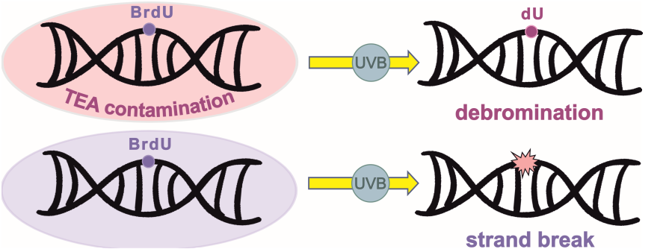

PET between TEA and BrdU was additionally confirmed by the UV irradiations of aqueous solutions containing both species. Indeed, the efficient formation of 2′-deoxyuridine was observed in the studied photolytes. Moreover, we showed the formation of an additional product in these mixtures, i.e. imidazole derivative, that is not formed in DNA and was reported in the literature in the context of dark rather than photochemical processes.

Acknowledgements. This work was supported by the Polish National Science Centre (NCN), Grant No. 2014/14/A/ST4/00405 (J.R).

References:

(1) J. Phys. Chem. B, 119.26 (2015): 8227-8238

(2) J. Phys. Chem. B, 118.19 (2014): 5009

**New semiconductor materials for photocatalytic hydrogen generation**

*Julia Zwara1, Marta-Paszkiewicz Gawron1, Ewelina Grabowska1, Justyna Łuczak2,*

*Adriana Zaleska-Medynska1*

[1] Faculty of Chemistry, University of Gdansk, Wita Stwosza 63, 80-308 Gdansk, Poland

[2] Gdansk University of Technology, G. Narutowicza 11/12, 80-233 Gdansk, Poland

Recently, new materials that are involved in minimizing environmental pollution and related risks are increasingly being sought for. Moreover, great interest is focused on obtain hydrogen during photocatalytic process in the presence of semiconductors nanoparticles and UV-Vis or solar irradiation. Ionic liquids (ILs) are widely applied to prepare metal nanoparticles and 3D semiconductor microparticles due to their unique properties do not cause vapor emission into the environment, which is an alternative to commonly used organic solvents [1]. Generally, they serve as a structuring agent or reaction medium (solvent), however it was also demonstrated that ILs can play a role of a co-solvent, reducing as well as surface modifying agent. In addition, ionic liquids in combination with semiconductors characterized by a narrow energy gap are likely to exhibit the highest photoactivity in the degradation process. Figure 1 shows a schematic illustration of band structures of selected semiconductor photocatalysts for testing.

In view of this, the aim of this work was to obtain new semiconductors such as: AgNbO3, AgTaO3, SrTiO3, SrSnO3, GaFeO3, FeVO4 during the hydrothermal process in the presence of ionic liquid (1-butyl-3-methylimidazolium bromide [BMIM]Br). Characterization of obtained semiconductors included morphology analysis using scanning electron microscopy (SEM), absorption spectra, surface area analysis BET and phase composition analysis using X-ray diffraction (XRD).

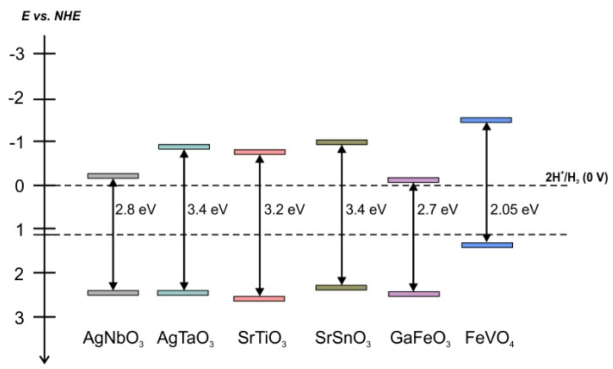

Figure 1 Schematic illustration of band structures of selected semiconductor photocatalysts

**References:**

[1] R. Vekariya, Journal of Molecular Liquids, 227 (2017) 44-60

**Acknowledgements:**

The authors acknowledge funding from the National Science Center within the program OPUS 13, research grant: “New semiconductor materials for photocatalytic hydrogen generation: mechanism formation in the presence of ionic liquids”, contract No. UMO-2017/25/B/ST8/0111.